**CHAPTER - I**

**INTRODUCTION**

**Introduction**

In the world of software development there lots of improvement in the area of Architectural design and principles. The philosophies and implementation details are changing as the people guiding the development of the application.

In this fantastic and yet sometimes complex world of software development there are some tried and true architecture patterns and software development guidelines employed by most architects.

Also your design must have an ability to turn towards innovation instead of lending itself to common practices. Web services are one such area where architects must lean on their creative side and hope that their solutions are still successful.

In this report we will explain an exciting voyage down the road of Web services application.

From requirements to use cases, to database design, to component

frameworks, to user interfaces, we will cover each and every aspect of system design required to build an application with collaborative Web services. The reason why we selected online Bookstore web service is everybody walking down the street has some idea about bookstores.

The objective of this project is to develop an e- book store where books can be bought from the comfort of home through the Internet.

An online book store is a virtual store on the Internet where customers can browse the catalog and select books of interest. The selected books may be collected in a

shopping cart.

At checkout time, the items in the shopping cart will be presented as an

order. At that time, more information will be needed to complete the transaction.

Usually, the customer will be asked to fill or select a billing address, a shipping address, a shipping option, and payment information such as credit card number.

An e-mail notification is sent to the customer as soon as the order is placed.

1. **Background**

**Organizational Overview:**

**Project Name:** E-Book Store Management System

**Objectives:** To make attractive website for overcome workload.

**Location:** At/post- Talere (RaguchiWadi),tal: Kanakawali,dist: Sindhudurg.

**Pincode:** 416801

**Phone No. :** 7020767185

**Affiliation :** U.G.C. & Govt.Maharashtra Funded University opf Mumbai’s Model College.

**About E-Book Store Management System:**

To develop an effective system that is fast accurate, consistent, reliable and flexible enough so that it can accommodate any further expansion.

**Co-ordinator of the cell:**

Dr.A.S. Kulkarni.(Co-ordinator, V. V. Dalvie College,Talere).

* The current e-book store management system is handled manually i.e. the data is handled by designed personals. The data is store in the files.
* The processing is done manually, the report generation is slow. Data required cannot be accessed faster.
* The data is stored in various registers to the linking between it is difficult.
* It the lying faces down to manual errors.

1. **Purpose, Goals:**

**Purpose:**

To provide non-technical computer users—in particular senior citizens—with an inexpensive, accessible source of information about how to use the Internet search engine Google.

**Goals:**

* To sell the book through Amazon.com.
* To offer the book at a competitive price.
* To write the book in an accessible style that is appropriate for its audience.
* To cover the basics of using Google in 25 self-contained tasks.
* To complete the book using a minimum amount of human capital.
* To develop a publishing process that can be applied to future book projects.

1. **Objectives:**

* To list the book for sale on Amazon.com by May 20, 2005, when the spring semester ends.
* To earn enough money in Amazon.com sales by December 31, 2005, to have paid for all non-labour expenses.
* This allows user to know about each other and their current activities.
* E-Book Store Management System is to develop web page which manages records of Book Store.

1. **Achievements**

**Proposed** **System**: **“E-book store management system”** for many clinics

Some of the achievement of the projects is as follows:

1. New and attractive software will fulfill the requirement.
2. No manual work is required
3. Record keeping becomes easy
4. No paperwork is required
5. Easy to search any record
6. Save time & effort
7. **Organization of Report**

Chapter 1 to 4 (Introduction, Survey of Technologies, Requirement & Analysis, System Design) covered in this documentation. The following chapter is to be included:

**Chapter 1: Introduction**

In the first chapter, describe the introduction of project. That can include background, objective, purpose, scope, applicability of the project.

**Chapter 2: Survey of Technologies**

In this chapter survey of technologies should demonstrate the awareness and understanding of available technologies related to the topic of the project.

**Chapter 3: Requirement and Analysis**

In this chapter define the requirement of the project and analyse this requirement. This includes problem definition, requirement specification, and software and hardware requirement.

**Chapter 4: System Design**

In this chapter, describe feature and operation in detail, including screen layouts, business rules, process diagram, pseudo code and other documentation.

**CHAPTER - II**

**SURVEY OF TECHNOLOGIES.**

**Technologies and Tools Used**

The following technologies are used in both client and server side:

1. **Hyper Text Markup Language (html) 4.0:**

It is a publishing language for the World Wide Web. It supports text, multimedia, hyperlink, multimedia options, scripting languages, stylesheet, better printing facilities, and documents those are more accessible to users with disabilities.

It is also takes great strides towards the internationalization of documents, with the goal of making the web truly worldwide. To describe the contents should look of the documents like head, title, body, paragraph, table, form, image etc.

1. **Active server pages (ASP) .Net:**

Asp is Microsoft’s server side technology for dynamically generated web pages that is marketed as an add-on to internet information services (IIS). Programming ASP websites is made easier by various built in objects. Each object corresponds to a group of frequently used functionality useful for creating dynamic web pages. ASP is used in administrator site for valid log in and maintaining session state.

1. **ADO.Net:**

ADO.Net stands for ActiveX Database Object. It is Microsoft’s special technology to carry out database connectivity with .Net compatible languages.

**Tools:**

* MS Visual Studio 2008
* Adobe Photoshop CS3
* Nitro Pdf Converter
* Adobe Dreamweaver
* Internet Explorer 9
* Google chrome Version 23.0.1271.97 m
* Mozilla Firefox 12.0
* Microsoft Edge

1. **JavaScript:**

JavaScript is a script language a system of programming codes, created by Netscape that can be embedded into the html of a web page to add functionality.

They are used in the site for

* JavaScript is used for acquiring client-side validations of html forms.
* Also it is used for sever-side validation too.
* Scripts are included in the web pages mostly in the head tags itself.

1. **Cascading Style Sheet:**

Cascading Style Sheet (CSS) is a simple mechanism for adding style (e.g. fonts, colours and spacing) to web documents.

They are used for:

* Maintaining the look and feel of the site throughout.
* Easy updating in the look and feel (i.e. change in .css file).

**CHAPTER - III**

**REQUIREMENT AND ANALYSIS**

1. **Problem Definition:**

**Description of System**

**URL:-** https://hamlet-ebook.wix.com/website

The e-book store management system is very beneficial for an authors/readers. It will stores complete e-book record. The most important thing is it will make it easier for the retrieval of history information of the user with e-books.

E-Book Store Management System is developed to improve the book shops management and automates the work flow that happens in the library. This system is considering all the activities in the library.

Users will make registration first. If the user never registered before, user information collected and stored in the database. However, if it is an existing user the user data is search-using ID no. This will improve the record of the user and save the time during the registration.

E-book Store Management System has no any application which handles all the data of the user or publisher as per their requirement.

All the working of system is done manually and lots of paperwork is required. Keeping records of all user or publisher available become tedious job.

**Limitations of present System:**

The current system (Online System) of e-book management has following limitation:

1. No software available for clinic
2. All the work is done manually
3. Lots of paperwork is required
4. Recording keeping becomes tedious job.
5. There is no any way to search any information related to patient or employee
6. Updating records is tedious job.
7. **Requirement Specification.**

**Proposed System & It’s Advantages**

To overcome the limitation of the current system, proposed system ha following advantages.

**Proposed** **System**: - “**E-Book Store Management System”**

1. New and attractive website will fulfill the requirement.
2. No manual work is required
3. Record keeping becomes easy
4. No paperwork is required
5. Updating information is easy.

1. Easy to search any information related to user or publisher.

**Feasibility Study**

Project feasibility analysis is an activity that verifies whether a project can be started & successful completed.

Activities to confirm project Feasibility are as following.

1. **Risk Management**
2. **Economic Feasibility**
3. **Organizational & cultural feasibility**
4. **Technological feasibility**
5. **Schedule feasibility**
6. **Resource feasibility**
7. **Risk Management** :

Risk management concern with identifying the potential risk that may occur while performing project will be successfully completed. In my project online registration and notifying the applicants about jobs may produce some problems but they can be surely fixed by taking guidance from well skilled person having enough computer programming language Knowledge.

1. **Economic Feasibility** :

It consists of:-

1. Is the anticipated value of the benefits greater than projected cost of development?
2. Does the organization have adequate cash flow to fund the project during the development period?

* The project will earn annual saving as well as increased revenue.
* Reduced paperwork & save money needed for printing forms.
* The project will give intangible benefits like,

3) Increased level of organization’s member

4) Improved image of organization.

5) Save time of committee & Students.

1. **Organizational & Cultural Feasibility** :-

Each organization has its own culture

1. The committee is working under well-known organization (University of Mumbai.) so it is competent for website.
2. No members of committee will come across any loss.
3. **Technological Feasibility** :-

The developing project may produce challenges to current employee due for lack of knowledge. If the project needs expertise from outside location to maintain software the problems may occur regarding money.

* + The project technologically feasible as the organization have well skilled employee to maintain software
  + Organizations have enough computers with ideal configuration.

1. **Schedule Feasibility** :-

The deadline for the system implementation is 10th Feb. 2020.

* The phase as scheduled as,
* 30th Jun. 2019-Preliminary Investigation
* 22th Aug. 2019-Requirement Analysis
* 30th Sep. 2019- System Designing
* 15th Dec. 2019- System Coding (Expected.)
* 5th Jan. 2020-implementation (Expected.)
* 14th Jan. 2020-Project Reporting And Submission (Expected.)
  + The said project has been completed as per schedule. (Expected.)

Hence, the project passes schedule feasibility. (Expected.)

1. **Resource Feasibility :-**
   * The resources like computer, physical facilities are available.
   * Employees with enough programming skills are available to maintain S/W

Hence project passes resource feasibility.

As the project has passed all the feasibility tests, the project is available.

1. **Planning and Scheduling:**

**Detailed Life Cycle of Project**

We will follow the Waterfall Model of software Development Life Cycle for Developing the Software System.

Waterfall approach was first SDLC Model to be used widely in Software Engineering to ensure success of the project. In "The Waterfall" approach, the whole process of software development is divided into separate phases. In this Waterfall model, typically, the outcome of one phase acts as the input for the next phase sequentially.

The following illustration is a representation of the different phases of the Waterfall Model.



Maintainance

Deployment

Testing

Implementation

System Design

RequirmentAnalysis

* **The sequential phases in Waterfall model are −**
* **Requirement Gathering and analysis** − All possible requirements of the system to be developed are captured in this phase and documented in a requirement specification document.
* **System Design** − The requirement specifications from first phase are studied in this phase and the system design is prepared. This system design helps in specifying hardware and system requirements and helps in defining the overall system architecture.
* **Implementation** − With inputs from the system design, the system is first developed in small programs called units, which are integrated in the next phase. Each unit is developed and tested for its functionality, which is referred to as Unit Testing.
* **Integration and Testing** − All the units developed in the implementation phase are integrated into a system after testing of each unit. Post integration the entire system is tested for any faults and failures.
* **Deployment of system** − Once the functional and non-functional testing is done; the product is deployed in the customer environment or released into the market.
* **Maintenance** − There are some issues which come up in the client environment. To fix those issues, patches are released. Also to enhance the product some better versions are released. Maintenance is done to deliver these changes in the customer environment.
* **Waterfall Model – Application**
* Requirements are very well documented, clear and fixed.
* Product definition is stable.
* Technology is understood and is not dynamic.
* There are no ambiguous requirements.
* Ample resources with required expertise are available to support the product.
* The project is short.
* **Waterfall Model – Advantages**

Some of the major advantages of the Waterfall Model are as follows −

* Simple and easy to understand and use
* Easy to manage due to the rigidity of the model. Each phase has specific deliverables and a review process.
* Phases are processed and completed one at a time.
* Works well for smaller projects where requirements are very well understood.
* Clearly defined stages.
* Well understood milestones.
* Easy to arrange tasks.
* Process and results are well documented.
* **Waterfall Model – Disadvantages**

The major disadvantages of the Waterfall Model are as follows −

* No working software is produced until late during the life cycle.
* High amounts of risk and uncertainty.
* Not a good model for complex and object-oriented projects.
* Poor model for long and ongoing projects.
* Not suitable for the projects where requirements are at a moderate to high risk of changing. So, risk and uncertainty is high with this process model.
* It is difficult to measure progress within stages.
* Cannot accommodate changing requirements.
* Adjusting scope during the life cycle can end a project.
* Integration is done as a "big-bang. at the very end, which doesn't allow identifying any technological or business bottleneck or challenges early.

**Gantt Chart: -**

* + Gantt charts are usually created initially using an early start time approach, where each task is scheduled to start immediately when its prerequisites are complete.
  + This method maximizes the float time available for all tasks.
  + Gantt charts are sometimes equated with bar charts.

Gantt chart designed as per phases of Software Development and Life Cycle (Waterfall Model Approach).

**Fact Finding Techniques:**

The specific methods used for collecting data are called fact finding techniques. Fact finding techniques are follows

**1. Interview:-**

It is used to collect information from groups. There are 2 types of interviews.

* **Structured Interview:**

In this specific questions are asked for covered specific area.

* **Unstructured interview:**

In these different types questions are to collect extra information.

**2. Questionaries’:-**

Questionaries’ contains sequence of questions are asked to collect extra information from large no. of persons.

* **Open ended questions:**

Open ended questions are used to learn about the opinion, feelings general experience about the problem.

* **Close ended questions:**

Close ended questions contain specific questions and responses from which respondent has to choose best one.

* Why this system required?
* What are transactions of administrator?
* What about the result system?
* How they keep records about result?
* How they keep records about student?
* How this transaction they want?
* How many levels they want in admission process?
* How many streams involved in proposed system?
* Which type of information they displayed on front end?
* Any other information they want?

**GANTT CHART**

**Report Generation & Submission**

**Preliminary Investigation**

**June July Aug Sep Oct Nov Dec Jan Feb March**

**Testing & Validation**

**System**

**Coding**

**System**

**Design**

**System**

**Analysis**

Proposed Time

Actual Time

1. Software and Hardware Requirement

**Software Used:**

Front end: Microsoft Visual Studio 2010.

Back end: Microsoft SQL Server 2008 R2

Operating System: Windows 7.

Web Browser: Google Chrome, Mozilla Firefox, Microsoft Edge.

**Hardware Used:**

Processor: Intel Core i5

Memory: 4 GB RAM

Storage: Minimum 5GB of Hard disk Space.

**Tools Used:**

Report Viewer

STAR UML Diagram Tool

Microsoft Office Word 2013

1. **PRELIMANARY PRODUCT DESCRIPTION**

Event table is a list of events of a system in rows and information about each event like.

**1] Trigger –** An occurrence that initiates the event which is either the arrival of data or of a point in time.

**2] Source –** An external agent or actor that supplies data to the System.

**3] Activity –** Behavior of the system due to the occurrence of the event.

**4] Response –** An output produced by the system as a result of the event.

**5] Destination –** An external agent or actor that receives the response generated by the system.

|  |  |  |  |  |  |
| --- | --- | --- | --- | --- | --- |
| **Event** | **Trigger** | **Source** | **Activity** | **Response** | **Destination** |
| Hamlet E-book store login page | Access to homepage | Manager | Access / use Homepage | Access to Web Pages | Website / Portal |
| User Registration | User Details | User | Access the Log DB | Accept Information | E-book Store Portal |
| User Login | Access the page | User | Access the Data Information | Access the Web page | User Page |
| User check Books | Access the Web page | User | Take Data Information | Check Books Data | E-Book Page |
| User give Feedback | Make Report | User | Generate Report | Give us Reviews, Reports | User page |
| User/Publisher update  Books | Access the  Books | User / Publisher | Add Books | Update Books Data Base | Data Base Server |
| User download Books | Access The Books | User | Download books | Manipulate Data | Data server |
| User logout from web page | Leave the Web Page | User / Manager | Session Expired | Logout From Web page | 1. Book   Store Management |

1. **Conceptual Model**

**Submit/Register me/Add:**

By clicking this button data is stored on server and all the controls get refreshed and cleared. Then it will be ready for new record.

**Clear/Back/Cancel:**

By clicking this button all the controls get refreshed and cleared. Then it will be ready for next record to enter.

**Login:**

Used for logging in to particular account.

**Search:**

Used for logging in to particular account.

**First/Next/Previous/Last:**

Navigate to first/next/previous/last record in the particular form

**Update/save changes:**

This button is used to update the records/profiles.

**Delete:**

Admin can delete data and user can delete its account by clicking this button.

**Pre-Flow Charts & System Flow Charts**

Following symbols used to draw system flowchart :-

1. Used for process
2. Used for predefined process
3. Used for documents
4. Used for manual operation
5. Used for online storage
6. Disk or direct access file
7. Used for manual input
8. Used for display

USER

LOGIN

Publisher Upload Books

Update & Download Books

Maintain Books

Get Books

End

**Entity Relationship Diagram :-**

An entity relationship diagram (ERD) shows the relationships of entity sets stored in a database. An entity in this context is a component of data. In other words, ER diagrams illustrate the logical structure of databases.

**Common Entity Relationship Diagram Symbols**

An ER diagram is a means of visualizing how the information a system produces is related. There are five main components of an ERD:

* **Entities**, which are represented by rectangles. An entity is an object or

Concept about which you want to store information.

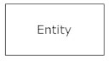

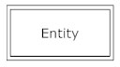

* **Actions**, which are represented by diamond shapes, show how two

Entities share information in the database.

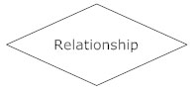

* **Attributes**, which are represented by ovals. A key attribute is the unique, distinguishing characteristic of the entity. For example, an employee's social security number might be the employee's key attribute.

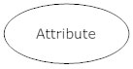

* **Connecting lines**, solid lines that connect attributes to show the relationships of entities in the diagram.
* **Cardinality** specifies how many instances of an entity relate to one instance of another entity.

**Entity Relationship Diagram :-**

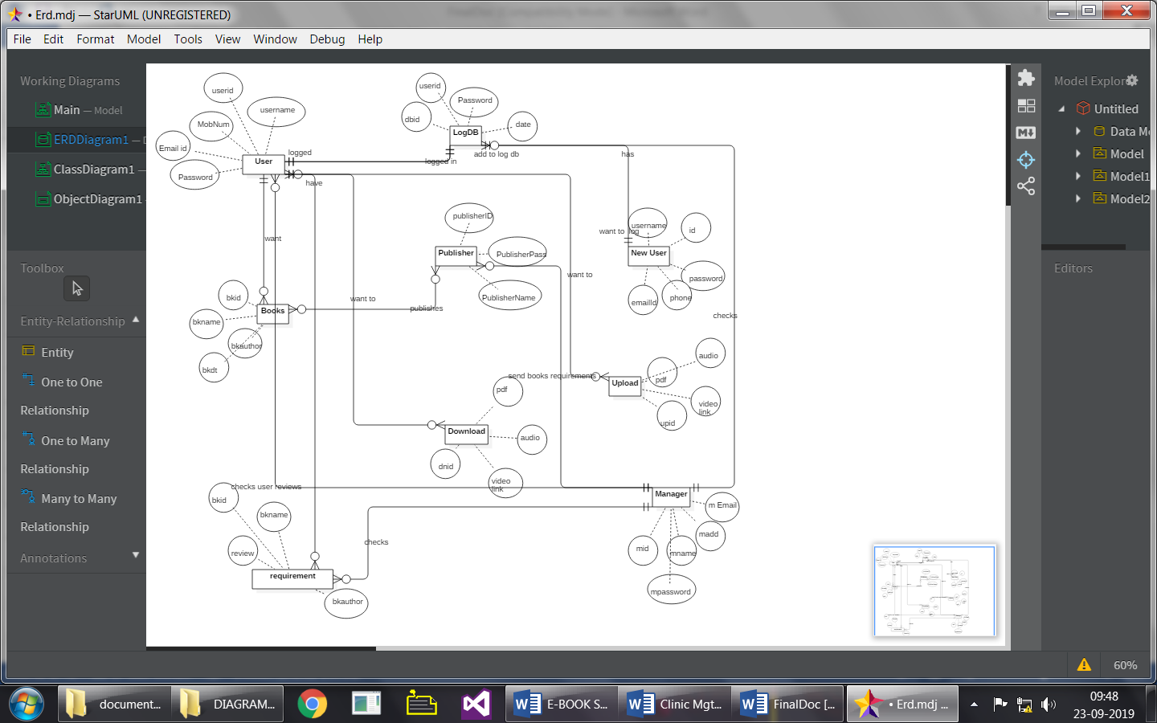

**Class Diagram :-**

A class diagram models the static structure of a system. It shows relationships between classes, objects, attributes, and operations.

## Basic Class Diagram Symbols and Notations :-

## Classes

Classes represent an abstraction of entities with common characteristics. Associations represent the relationships between classes.

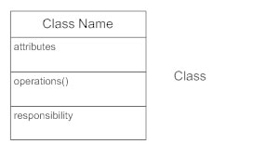

#### Active Classes

Active classes initiate and control the flow of activity, while passive classes store data and serve other classes. Illustrate active classes with a thicker border.

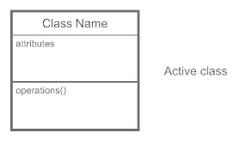

#### Visibility

Use visibility markers to signify who can access the information contained within a class.

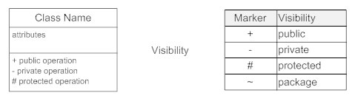

#### Associations

Associations represent static relationships between classes. Place association names above, on, or below the association line.

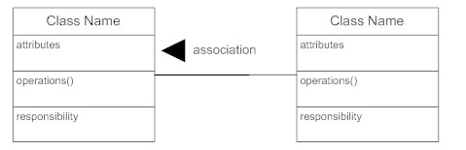

#### Multiplicity (Cardinality)

Place multiplicity notations near the ends of an association.

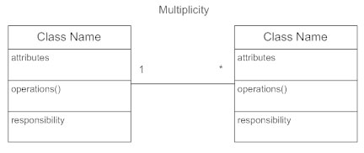

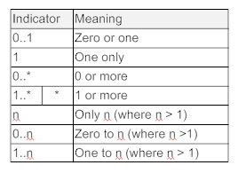

#### Constraint

Place constraints inside curly braces {}.

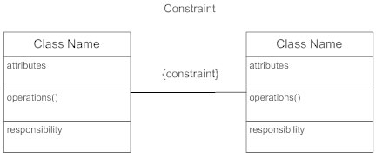

**Class Diagram :-**

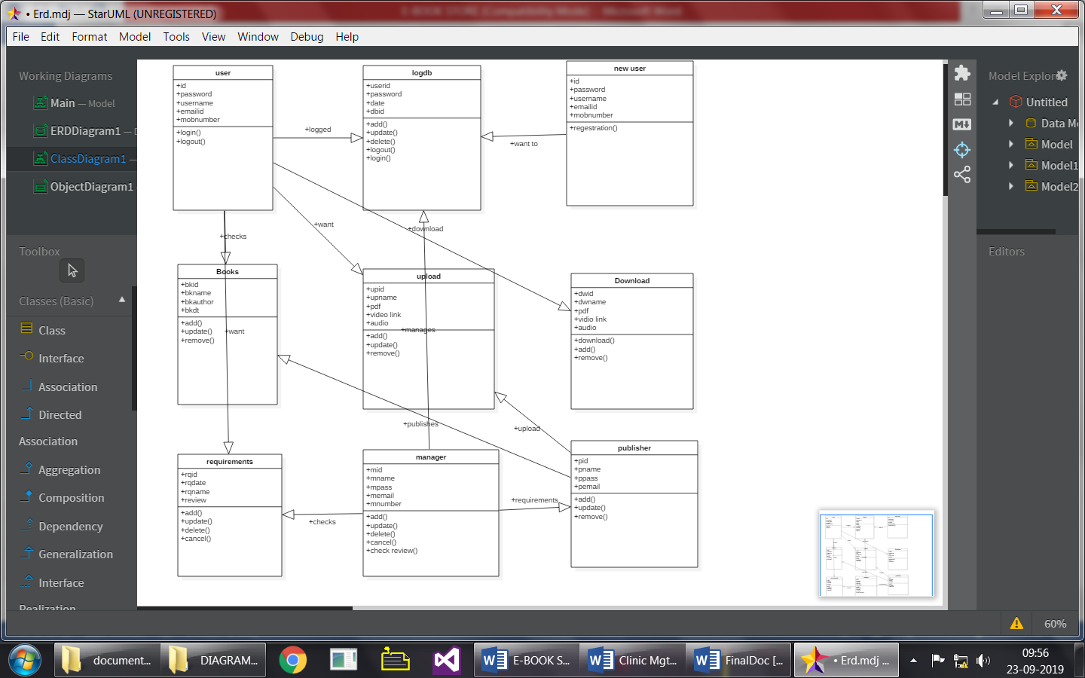

**Object Diagram :-**

Object diagrams are derived from class diagrams so object diagrams are dependent upon class diagrams.

Object diagrams represent an instance of a class diagram. The basic concepts are similar for class diagrams and object diagrams. Object diagrams also represent the static view of a system but this static view is a snapshot of the system at a particular moment.

Object diagrams are used to render a set of objects and their relationships as an instance.

**Object Names:**

* Every object is actually symbolized like a rectangle, that offers the name from the object and its class underlined as well as divided with a colon.

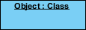

**Object Attributes:**

* Similar to classes, you are able to list object attributes inside a separate compartment. However, unlike classes, object attributes should have values assigned for them.

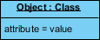

**Links:**

* Links tend to be instances associated with associations. You can draw a link while using the lines utilized in class diagrams.

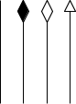

**Object Diagram :-**

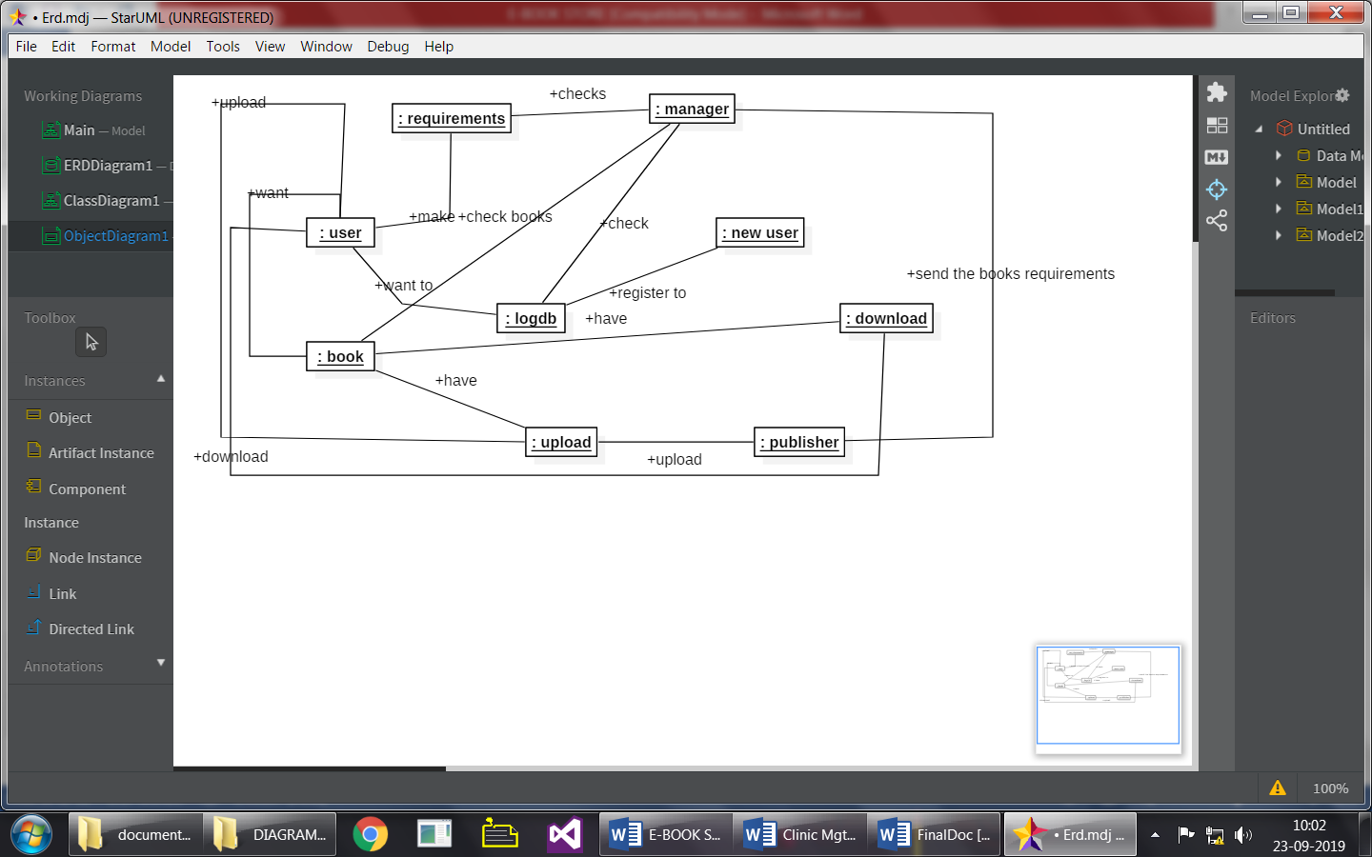

**Package Diagram :-**

It is used to identify major components of system .To simplify complex class diagram we can group classes into package .package is a collection of logically related UML elements.

**Symbols used for package Diagram:**



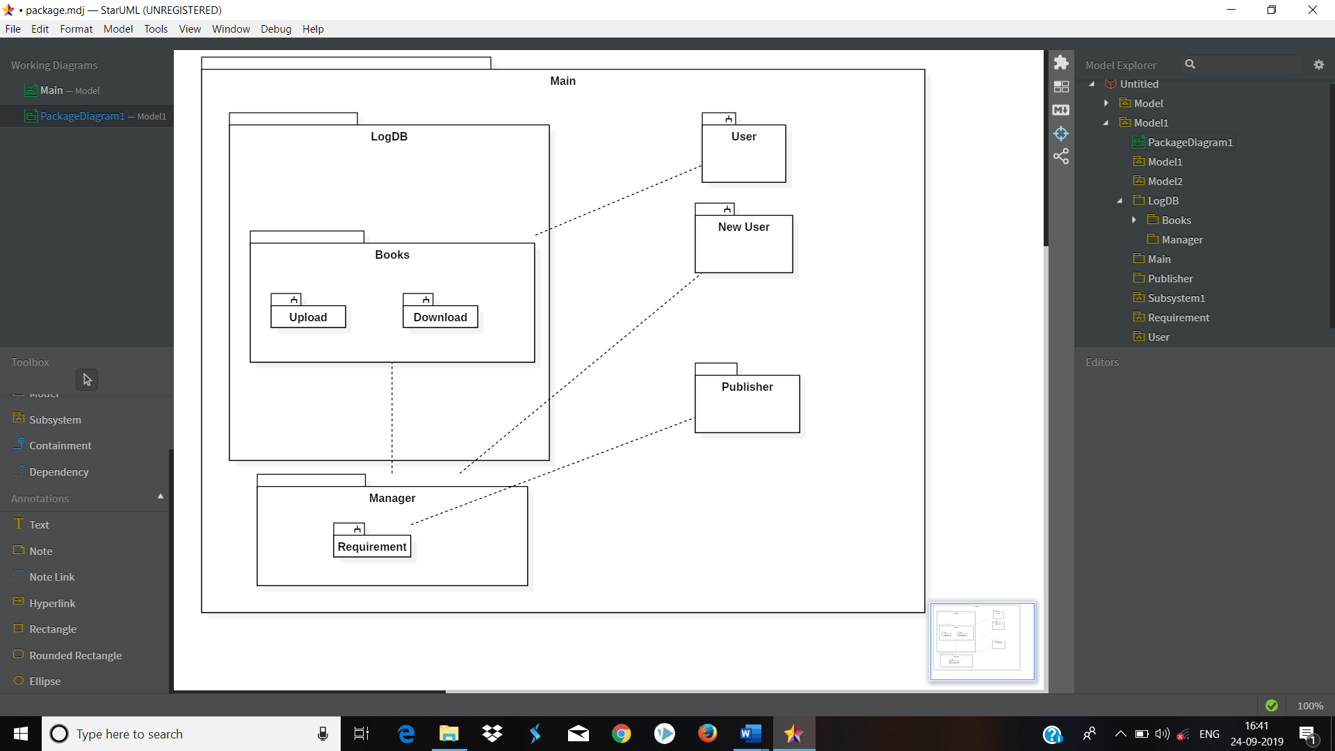

**Deployment Diagram :-**

The diagram shows physical layout various hardware component that compose a system as well as the substitution of executable program on this hardware.

**Representation of node:**

Each hardware resource is represented by a queue .Indicating the physical presence of the equipment in the system.

Node

The nature of the equipment may be specified using a stereotype

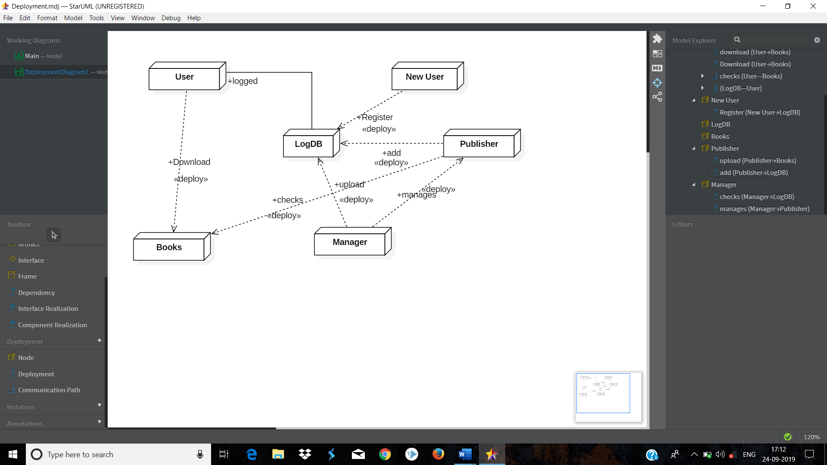

**Component Diagram :-**

Presence of association and role information shows that the diagram represents classes of nodes .The diagram shows a system composed of a server with surrounding PC’s that drive the opening and closing gates.

The number of PC’s has not been established conversely it appears that every PC may control at most 10 gates.3 x terminal play the role of console to access the system. A printer is connected to the server.

Component diagram describes software component and their relationship within the implementation environment.

**Symbols used for component Diagram:**



**Component Diagram : -**

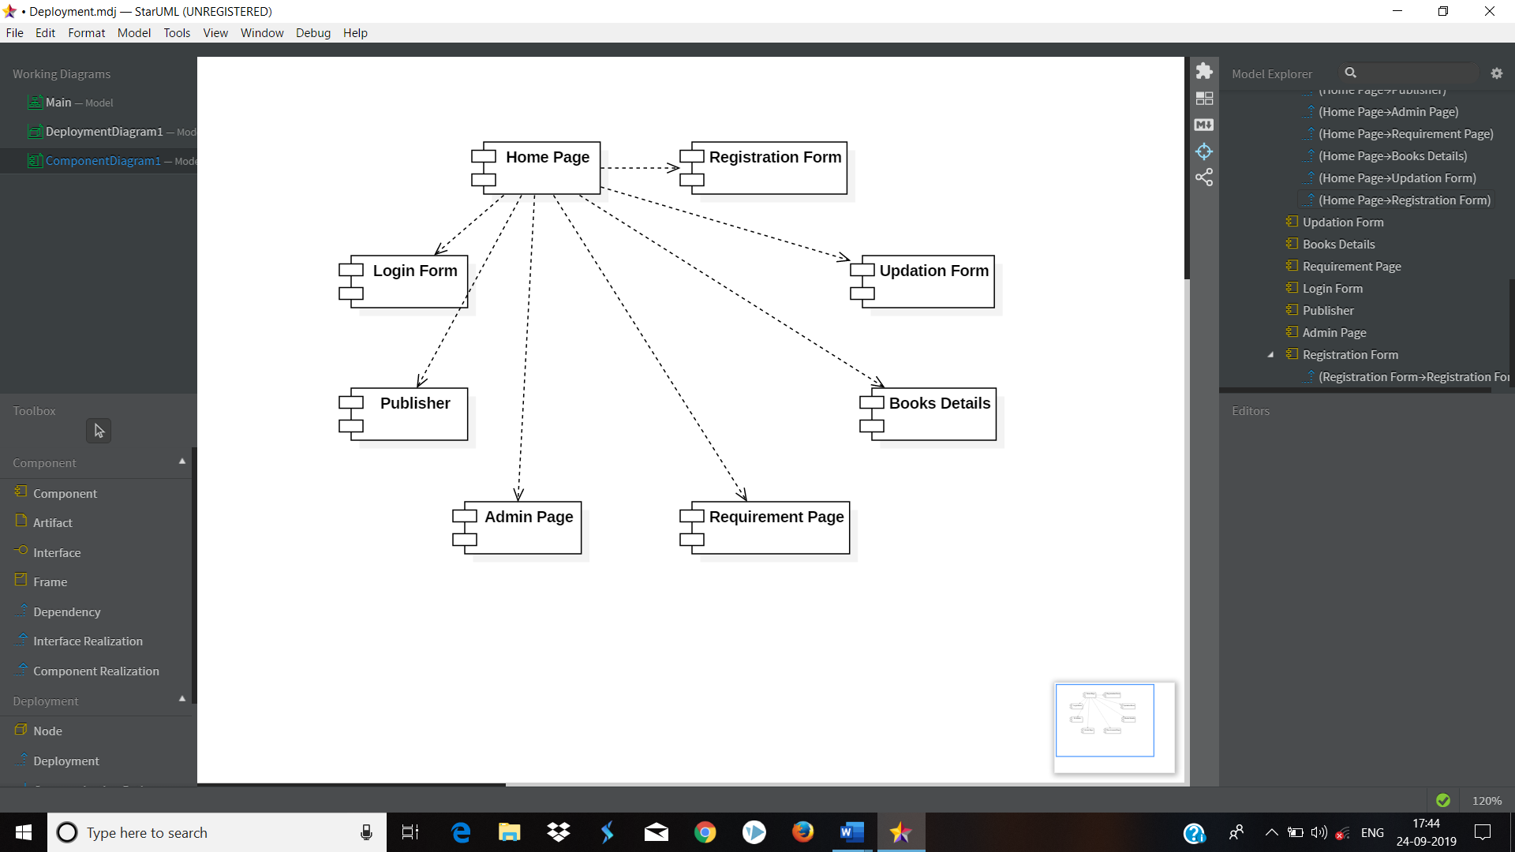

**State Transition Diagram :-**

State transition diagrams have been used right from the beginning in object-oriented modelling. The basic idea is to define a machine that has a number of states (hence the term finite state machine).

The machine receives events from the outside world, and each event can cause the machine to transition from one state to another. For an example, take a look at figure 1. Here the machine is a bottle in a bottling plant. It begins in the empty state. In that state it can receive squirt events.

If the squirt event causes the bottle to become full, then it transitions to the full state, otherwise it stays in the empty state (indicated by the transition back to its own state). When in the full state the cap event will cause it to transition to the sealed state. The diagram indicates that a full bottle does not receive squirt events, and that an empty bottle does not receive cap events. Thus you can get a good sense of what events should occur, and what effect they can have on the object.

State transition diagrams were around long before object modelling. They give an explicit, even a formal definition of behaviour. A big disadvantage for them is that they mean that you have to define all the possible states of a system. Whilst this is all right for small systems, it soon breaks down in larger systems as there is an exponential growth in the number of states.

This state explosion problem leads to state transition diagrams becoming far too complex for much practical use. To combat this state explosion problem, object-oriented methods define separate state-transition diagrams for each class. This pretty much eliminates the explosion problem since each class is simple enough to have a comprehensible state transition diagram.

The most popular variety of state-transition diagram in object methods is the Harrell State chart as in Figure 1. This was introduced by Rumbaugh, taken up by Brooch and adopted in the UML.

It is one of the more powerful and flexible forms of state transition diagram. A particularly valuable feature of the approach is its ability to generalize states, which allows you to factor out common transitions (thus I can show that the break event applies to both full and empty states by creating the super-state of in-progress). It also has a flexible approach to handling processing.

Processes that are instantaneous (i.e. cannot be interrupted) can be bound to the transitions or to the entry or exit of a state, these are called actions. Processes that are long (and can be interrupted) are bound to states, these are called activities.

Transitions can also have a condition attached to them, which means that the transition only occurs if the condition is true. There is also a capability for concurrent state diagrams, allowing objects to have more than one diagram to describe their behaviour.

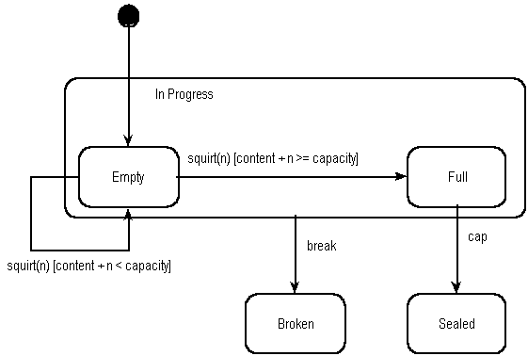

**State Transition Diagram : -**

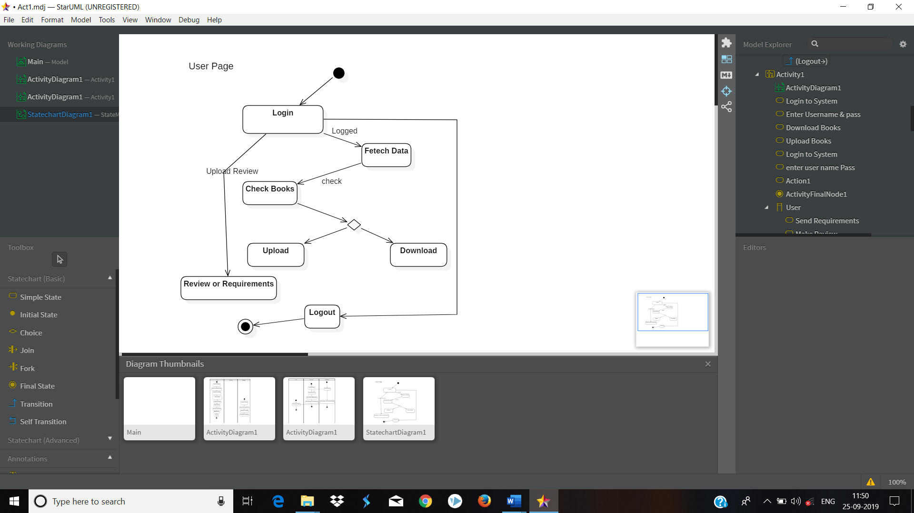

**CHAPTER – IV**

**SYSTEM DESIGN**

**Basic Modules:**

E-Book Store Management System provides the module like:

* + - 1. Manager
      2. User
      3. Publisher

**Manager**:

In this module, manager can inputs record about books or user and publisher . Manager can modify records and viewing changed record. Manager can login systems and handled the web pages.

Manager

Handled the web page

Log In

View details about

Update and Modify

**User:**

In this module, customer or users can access system and customer first register and input records. These records will be stored in database. Manager provide services via webpage to customer. Customer purchase or download or upload the books and make Editor page.

Customer

Login

View book details

Verify book details

Registration

**Publisher:**

In this module, creation of publisher in put records about career from pushing status for the user that all facilities to modify the records of updating books and the deleting books and viewing changed records.

Publisher

Login

View uploading status

Delete older books

Registration

**DATA DESIGN**

**SCHEMA DESIGN**

**Table No. 1) Registration Table For The User/ Publisher: -**

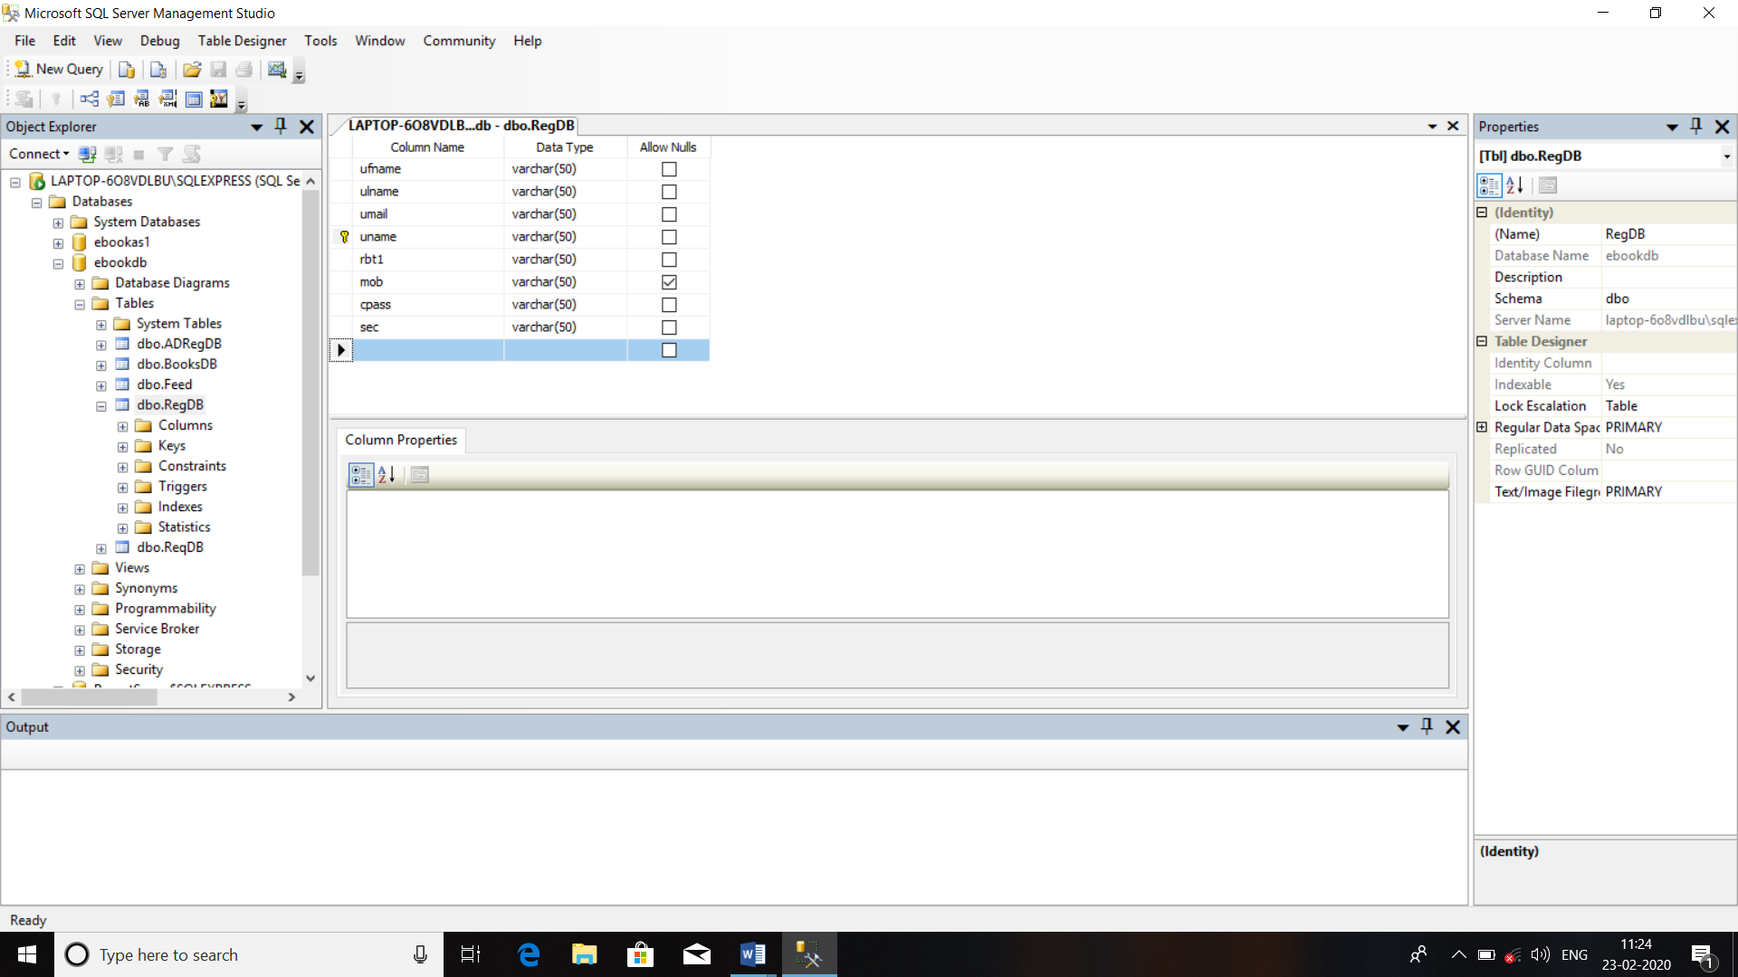

**Table No. 2) Admin Registration Table: -**

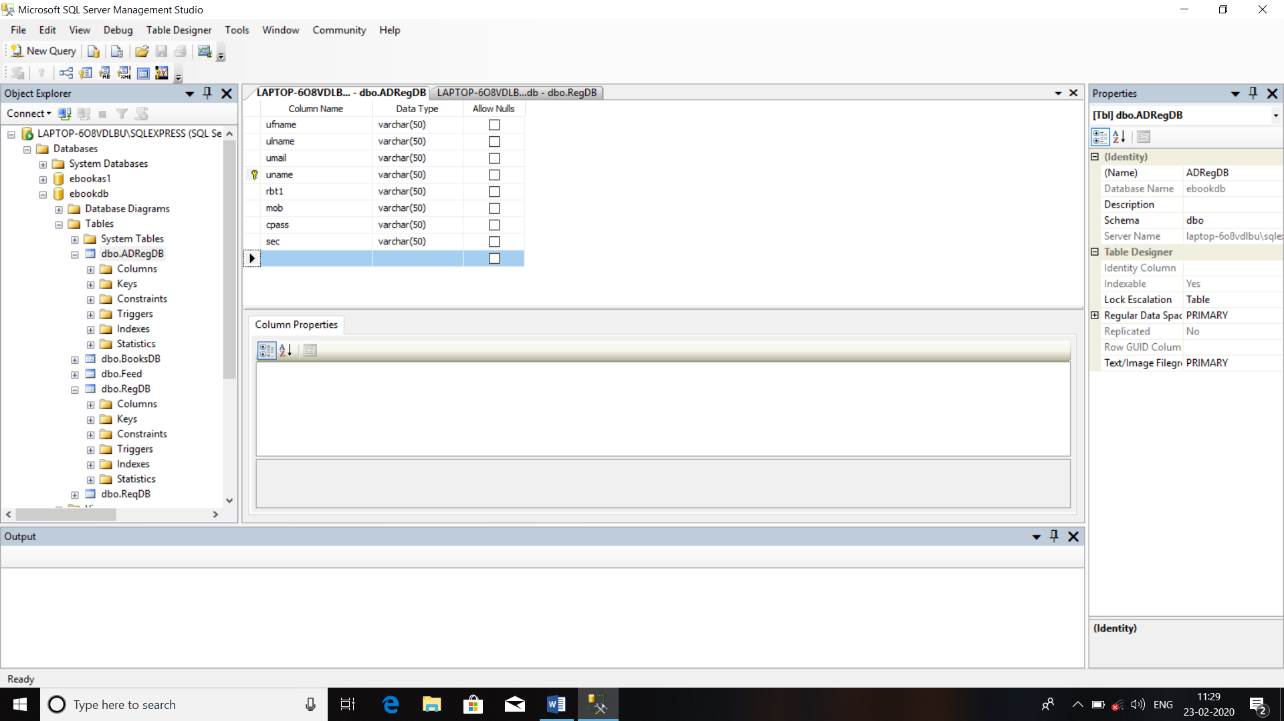

**Table No. 3) Books Details Table: -**

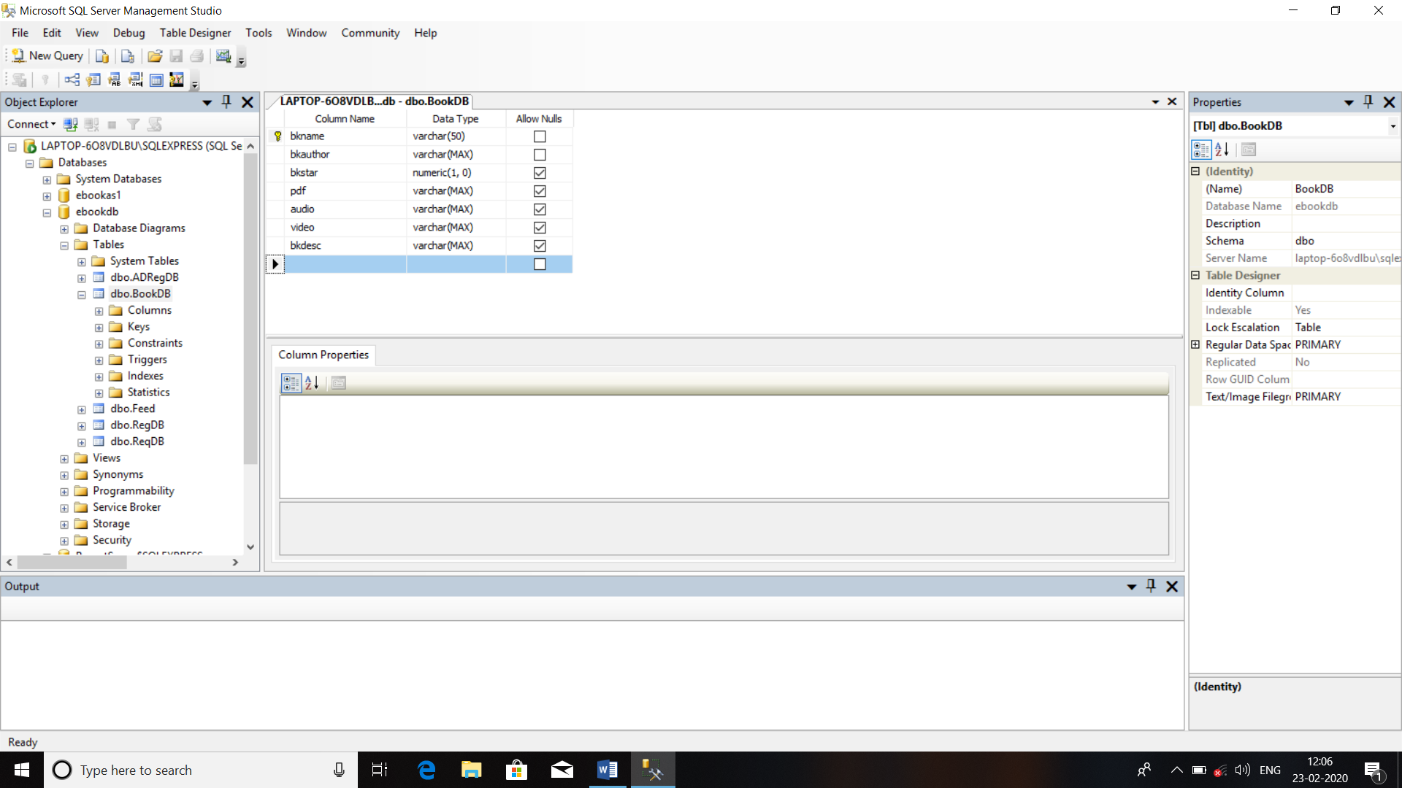

**Table No. 4) Requirements of Book Table: -**

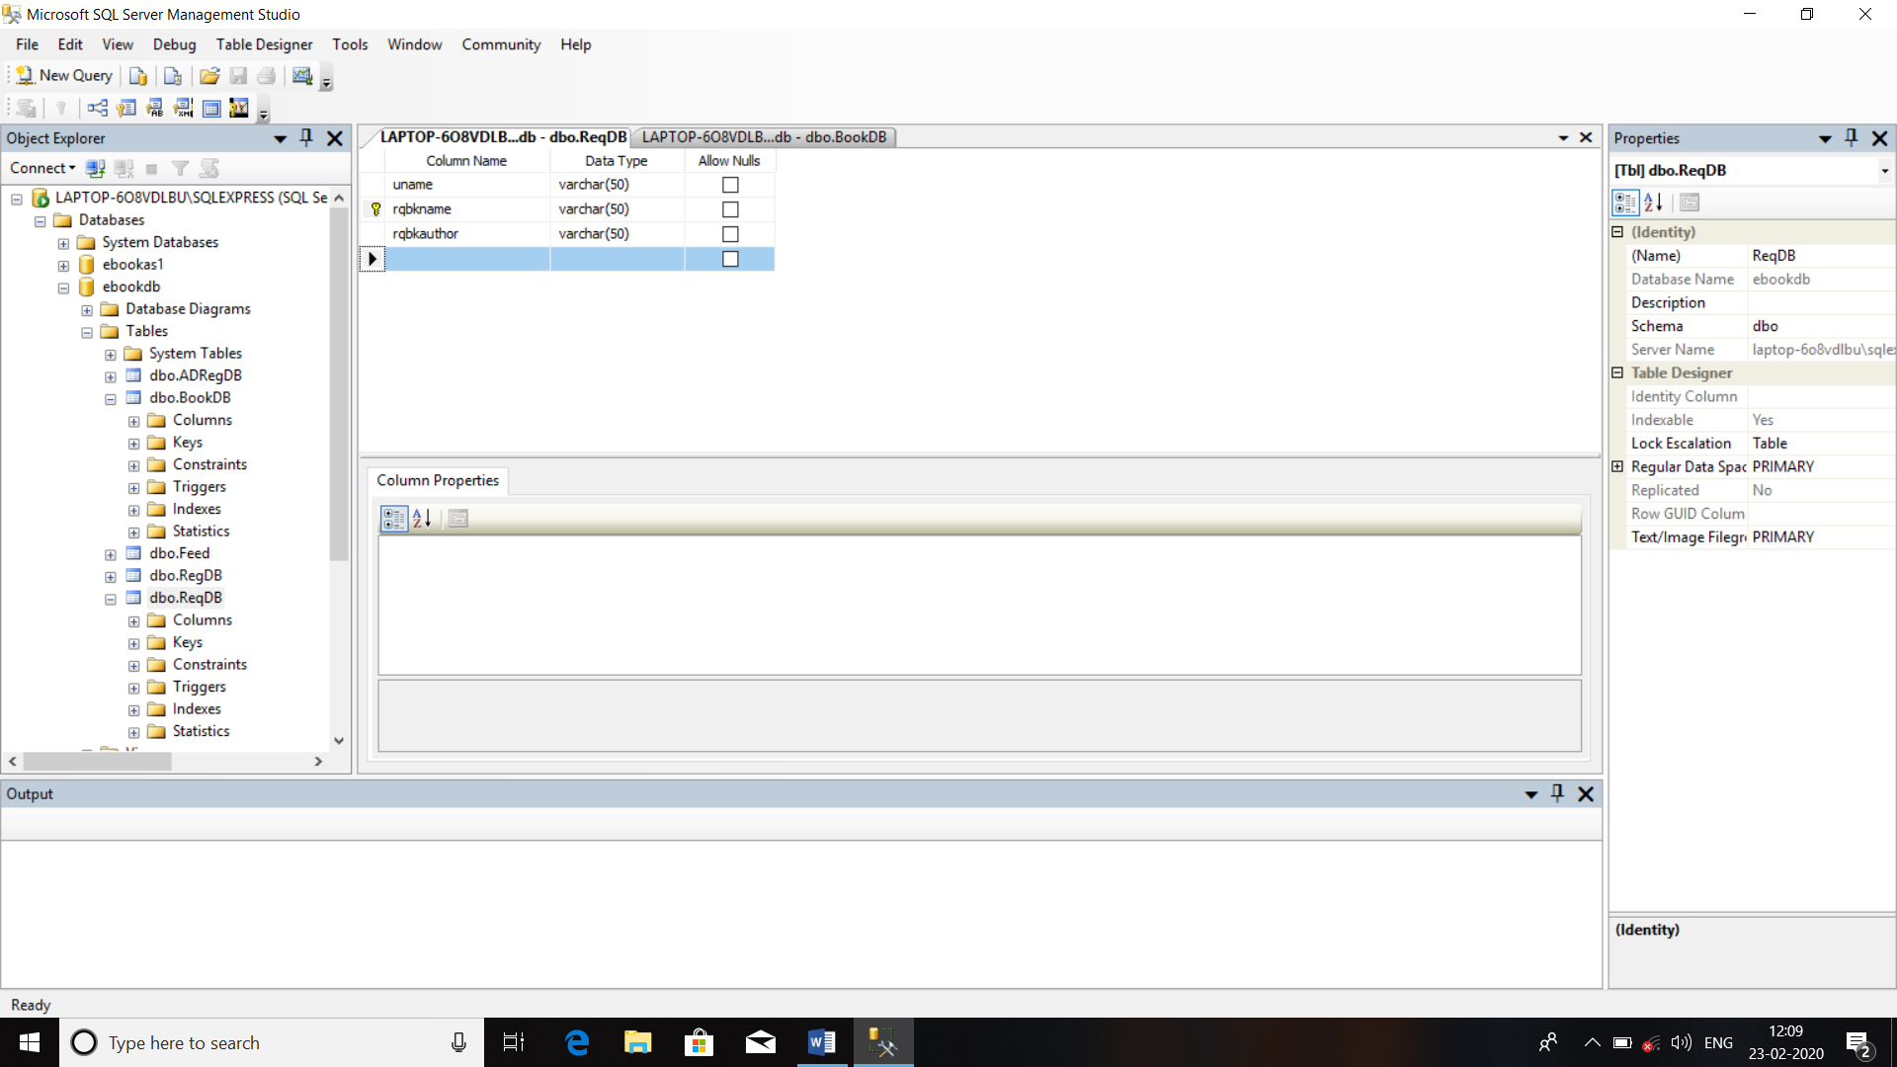

**Table No. 5) Feedback of User: -**

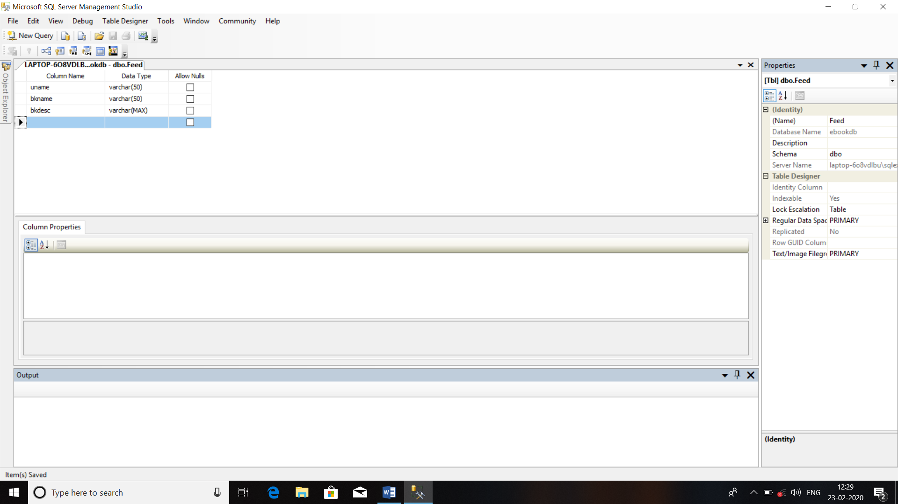

**Data Integrity and Constraints:**

**Table No.01: User Table**

|  |  |  |  |
| --- | --- | --- | --- |
| **Field Name** | **Data Type** | **Integrity & Constraints** | **Description** |
| **Uid** | **int** | **Primary Key** | **Id of User** |
| **Uname** | **Varchar(50)** | **Not Null** | **Name of User** |
| **Upass** | **Varchar(50)** | **Not Null** | **Password of User** |
| **Udate** | **Date** | **Not Null** | **DOB of User** |
| **Umail** | **Varchar(50)** | **Not Null** | **E-mail of User** |
| **Umob** | **Int** | **Not Null** | **Mobile No. Of User** |

**Table No.02: New User Table**

|  |  |  |  |
| --- | --- | --- | --- |
| **Field Name** | **Integrity & Constraints** | **Data Type** | **Description** |
| **Uid** | **Primary Key** | **int** | **Id of User** |
| **Uname** | **Not Null** | **Varchar(50)** | **Name of User** |
| **Upass** | **Not Null** | **Varchar(50)** | **Password of User** |
| **Udate** | **Not Null** | **Date** | **DOB of User** |
| **Umail** | **Not Null** | **Varchar(50)** | **E-mail of User** |
| **Umob** | **Not Null** | **Int** | **Mobile No. Of User** |

**Table No.03: LogDB Table**

|  |  |  |  |
| --- | --- | --- | --- |
| **Field Name** | **Data Type** | **Integrity & Constraints** | **Description** |
| **Lid** | **int** | **Primary Key** | **Id of LogDB** |
| **Bkid** | **int** | **Foreign Key** | **Book Id of LogDB** |
| **Uid** | **int** | **Foreign Key** | **User Id of LogDB** |
| **Mid** | **int** | **Foreign Key** | **Manager Id of LogDB** |
| **Pbid** | **int** | **Foreign Key** | **Publisher Id of LogDB** |

**Table No.04: Upload Table**

|  |  |  |  |
| --- | --- | --- | --- |
| **Field Name** | **Data Type** | **Integrity & Constraints** | **Description** |
| **Upid** | **int** | **Primary Key** | **Id of Uploader** |
| **Upname** | **Varchar(50)** | **Not Null** | **Name of Uploader** |
| **Uppdf** | **Varchar(50)** | **Allow Null** | **PDF Upload Link** |
| **Upaudio** | **Varchar(50)** | **Allow Null** | **Audio Upload link** |
| **Upvideo** | **Varchar(50)** | **Allow Null** | **Video Upload Link** |

**Table No.05: Download Table**

|  |  |  |  |
| --- | --- | --- | --- |
| **Field Name** | **Data Type** | **Integrity & Constraints** | **Description** |
| **Dwid** | **int** | **Primary Key** | **Id of Downloader** |
| **Dwname** | **Varchar(50)** | **Not Null** | **Name of Downloader** |
| **Dwpdf** | **Varchar(50)** | **Allow Null** | **PDF Download Link** |
| **Dwaudio** | **Varchar(50)** | **Allow Null** | **Audio Download link** |
| **Dwvideo** | **Varchar(50)** | **Allow Null** | **Video Download Link** |

**Table No.06: Publisher Table**

|  |  |  |  |  |
| --- | --- | --- | --- | --- |
| **Field Name** | **Data Type** | | **Integrity & Constraints** | **Description** |
| **Pbid** | **Int** | **Primary Key** | | **Id of Publisher** |
| **Pbname** | **Varchar(50)** | **Not Null** | | **Name of Publisher** |
| **Pbadd** | **Varchar(50)** | **Not Null** | | **Address of Publisher** |
| **Pbmail** | **Varchar(50)** | **Not Null** | | **E-mail of Publisher** |
| **Pbpass** | **Varchar(50)** | **Not Null** | | **Password of Publisher** |
| **Pbmob** | **int** | **Not Null** | | **Mobile No. Of Publisher** |

**Table No.07: Requirements Table**

|  |  |  |  |
| --- | --- | --- | --- |
| **Field Name** | **Data Type** | **Integrity & Constraints** | **Description** |
| **Rqid** | **Int** | **Primary Key** | **Id of Requirements** |
| **Rqname** | **Varchar(50)** | **Not Null** | **Name of Book** |
| **Rqreview** | **Varchar(50)** | **Not Null** | **Reviews of Book** |
| **Uid** | **Varchar(50)** | **Foreign Key** | **Id of user** |
| **Rqdate** | **Date** | **Not Null** | **Date of Requirements** |

**Table No.08: Books Table**

|  |  |  |  |
| --- | --- | --- | --- |
| **Field Name** | **Data Type** | **Integrity & Constraints** | **Description** |
| **Bkid** | **Int** | **Primary Key** | **Id of Books** |
| **Bkname** | **Varchar(50)** | **Not Null** | **Name of Books** |
| **Bkreview** | **Varchar(50)** | **Not Null** | **Description of Books** |
| **Bkdet** | **Varchar(50)** | **Not Null** | **Author,Publisher of Books** |
| **BkDate** | **Date** | **Not Null** | **Date of Publishing** |
| **Bkauthor** | **Varchar(50)** | **Not Null** | **Author Name with Details** |

**Table No.09: Manager Table**

|  |  |  |  |
| --- | --- | --- | --- |
| **Field Name** | **Data Type** | **Integrity & Constraints** | **Description** |
| **Mid** | **Int** | **Primary Key** | **Id of Manager** |
| **Mname** | **Varchar(50)** | **Not Null** | **Name of Manager** |
| **Mmail** | **Varchar(50)** | **Not Null** | **E-mail Id of Manager** |
| **Mpass** | **Varchar(50)** | **Not Null** | **Password of Manager** |
| **Madd** | **Varchar(50)** | **Not Null** | **Address of Manager** |
| **Mmob** | **Int** | **Not Null** | **Mobile No. Of Manager** |

**Table No.10: Forgot Password Table**

|  |  |  |  |
| --- | --- | --- | --- |
| **Field Name** | **Data Type** | **Integrity & Constraints** | **Description** |
| **Fid** | **Int** | **Primary Key** | **Id of Forgot Password** |
| **Uid** | **Int** | **Foreign Key** | **Id of User** |
| **Umail** | **Varchar(50)** | **Not Null** | **E-mail of User** |
| **Umob** | **Int** | **Not Null** | **Mobile No. Of User** |
| **Uname** | **Varchar(50)** | **Not Null** | **Name of User** |

**Table No.11: Delete Account Table**

|  |  |  |  |
| --- | --- | --- | --- |
| **Field Name** | **Data Type** | **Integrity & Constraints** | **Description** |
| **Dtid** | **Int** | **Primary Key** | **Id of Delete Table** |
| **Uid** | **Int** | **Foreign Key** | **Id of User** |
| **Upass** | **Varchar(50)** | **Not Null** | **Password Of User** |

**Table No.12: Change Password Table**

|  |  |  |  |
| --- | --- | --- | --- |
| **Field Name** | **Data Type** | **Integrity & Constraints** | **Description** |
| **CPid** | **Int** | **Primary Key** | **Id of Delete Table** |
| **Uid** | **Int** | **Foreign Key** | **Id of User** |
| **Upass** | **Varchar(50)** | **Not Null** | **Password Of User** |
| **Ulpass** | **Varchar(50)** | **Not Null** | **Password Of User** |

**Table No.13: Reviews Table**

|  |  |  |  |
| --- | --- | --- | --- |
| **Field Name** | **Data Type** | **Integrity & Constraints** | **Description** |
| **Rvid** | **Int** | **Primary Key** | **Id of Reviews** |
| **Rvname** | **Varchar(50)** | **Not Null** | **Name of Book** |
| **Rvreview** | **Varchar(50)** | **Not Null** | **Reviews of Book** |
| **Uid** | **Varchar(50)** | **Foreign Key** | **Id of user** |
| **Rvdate** | **Date** | **Not Null** | **Date of Reviews** |

**Table No.14: Security Key Table**

|  |  |  |  |
| --- | --- | --- | --- |
| **Field Name** | **Data Type** | **Integrity & Constraints** | **Description** |
| **Skid** | **Int** | **Primary Key** | **Id of Security Table** |
| **Uid** | **Int** | **Foreign Key** | **Id of User** |
| **SecKey** | **Varchar(50)** | **Not Null** | **Security Key Of User** |

**Logic Diagrams:**

**Use Case Diagram: -**

A [UML](https://en.wikipedia.org/wiki/Unified_Modeling_Language) use case diagram is the primary form of system/software requirements for a new software program under developed. Use cases specify the expected behavior (what), and not the exact method of making it happen (how).

Use cases once specified can be denoted both textual and visual representation (such as UML). A key concept of use case modeling is that it helps us design a system from end user's perspective. It is an effective technique for communicating system behavior in the user's terms by specifying all externally visible system behavior.

**Purpose of Use Case Diagram**

Use case diagrams are typically develop in early stage of development and people often apply use case modelling for the following purposes:

* Specify the context of a system
* Capture the requirements of a system
* Validate a systems architecture
* Drive implementation and generate test cases
* Developed by analysts together with domain experts

**Actor**

* Someone interacts with use case (system function).
* Named by noun.
* Actor plays a role in the business
* Similar to the concept of user, but a user can play different roles
* For example:

A prof. can be instructor and also researcher

plays 2 roles with two systems

* Actor triggers use case(s).
* Actor has responsibility toward the system (inputs), and Actor have expectations from the system (outputs).

**Use Case:**

Use case



* System function (process - automated or manual)
* Named by verb + Noun (or Noun Phrase).
* i.e. Do something
* Each Actor must be linked to a use case, while some use cases may not be linked to actors.

**Communication Link:**

The participation of an actor in a use case is shown by connecting a actor to a use case by a solid link.

Actors may be connected to use cases by associations, indicating that the actor and the use case communicate with one another using messages.

**Boundary of system:**

System

The system boundary is potentially the entire system as defined in the requirements document. For large and complex systems, each modules may be the system boundary. or example, for an ERP system for an organization, each of the modules such as personal, payroll, accounting, etc.

**Usecase Diagram:**

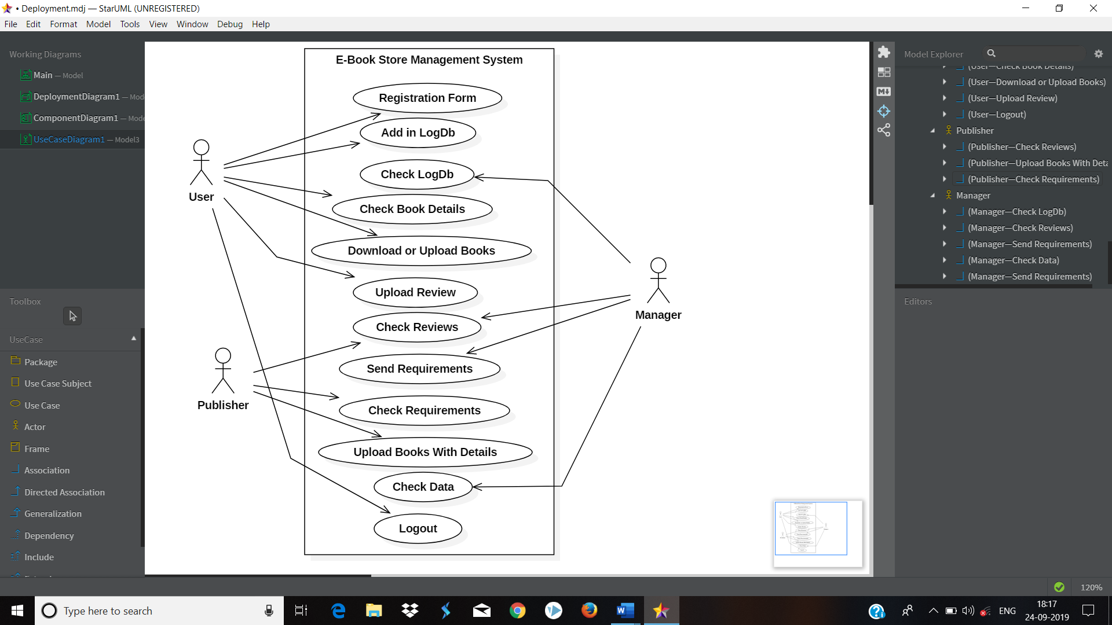

**Sequence Diagram: -**

Sequence diagram documents the information flows within a single use case or a single scenario.

Sequence diagram shows the sequence of the interaction between object that occurs during the flow of event of single scenario or use case.

**How to draw sequence diagram:**

1] Identify all object and actors that involved in scenario

2] Based on the flow activities, identify each message that will be required to carry out the scenario. Identify both the source object and the actor for message and destination object or actor.

3] Determine whether each message is always sent or whether it is sent only under certain condition.

4] Sequence the message correctly and attach them to the appropriate life lines of the actors and objects.

5] Add formal syntax on the message to describe condition, message name, and passed parameters.

**Symbols used for sequence Diagram:**





**Sequence Diagram: -**

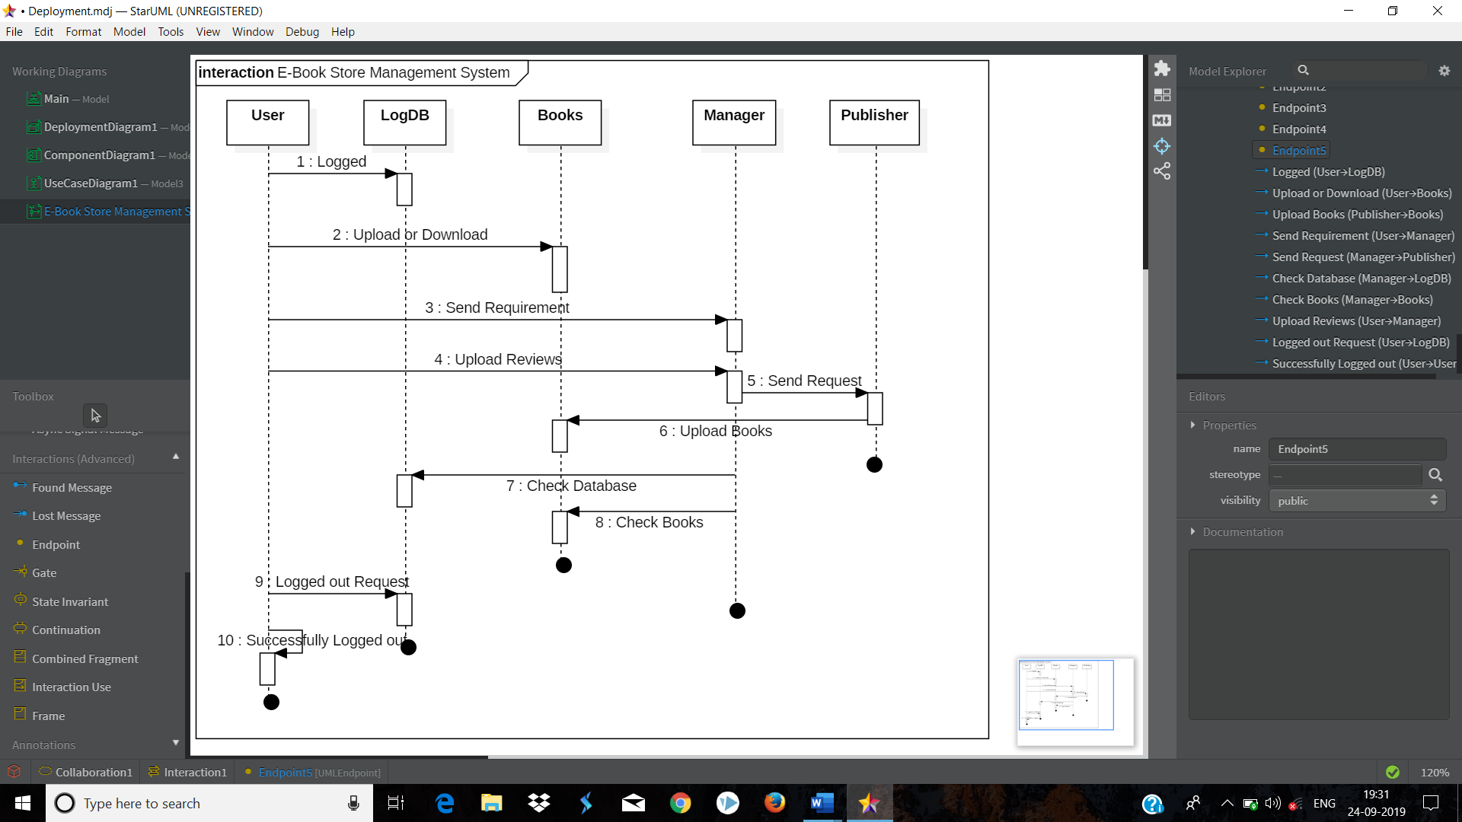

**Activity Diagram :-**

An activity diagram visually presents a series of actions or flow of control in a system similar to a flowchart or a data flow diagram.

## Basic Activity Diagram Notations and Symbols:

##### **Initial State or Start Point:**

A small filled circle followed by an arrow represents the initial action state or the start point for any activity diagram. For activity diagram using swim lanes, make sure the start point is placed in the top left corner of the first column.



##### **Activity or Action State:**

An action state represents the non-interruptible action of objects. You can draw an action state in Smart Draw using a rectangle with rounded corners.

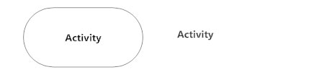

##### **Action Flow:**

Action flows, also called edges and paths, illustrate the transitions from one action state to another. They are usually drawn with an arrowed line.



##### **Object Flow:**

Object flow refers to the creation and modification of objects by activities.

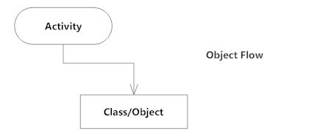

##### **Decisions and Branching:**

A diamond represents a decision with alternate paths. When an activity requires a decision prior to moving on to the next activity, add a diamond between the two activities.

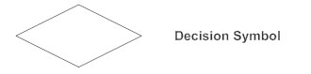

##### **Guards:**

In UML, guards are a statement written next to a decision diamond that must be true before moving next to the next activity.

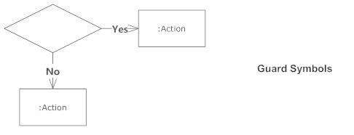

##### **Synchronization:**

A fork node is used to split a single incoming flow into multiple concurrent flows. It is represented as a straight, slightly thicker line in an activity diagram. A join node joins multiple concurrent flows back into a single outgoing flow.

A fork and join mode used together are often referred to as synchronization.

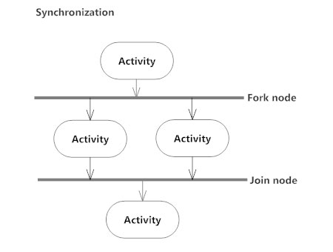

**Final State or End Point:**

An arrow pointing to a filled circle nested inside another circle represents the final action state.



**Activity Diagram: -**

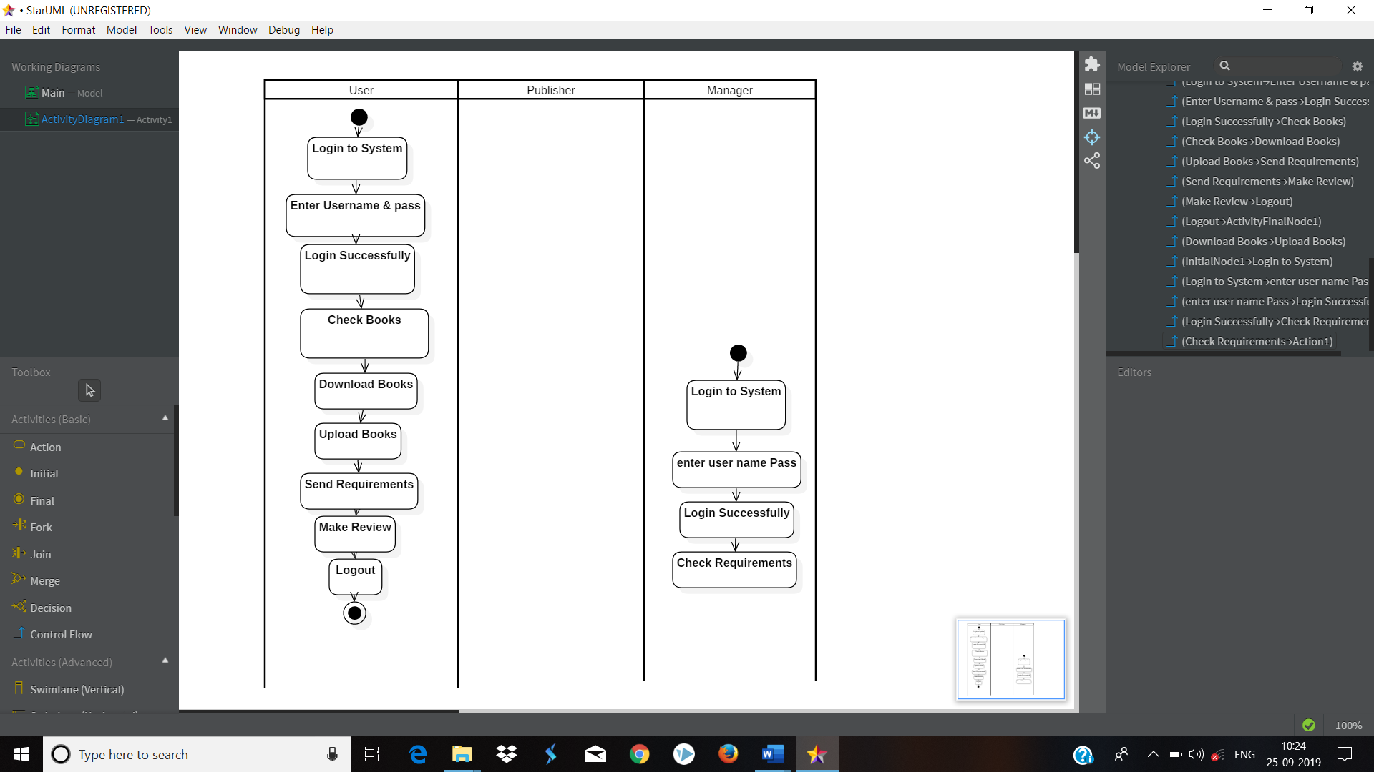

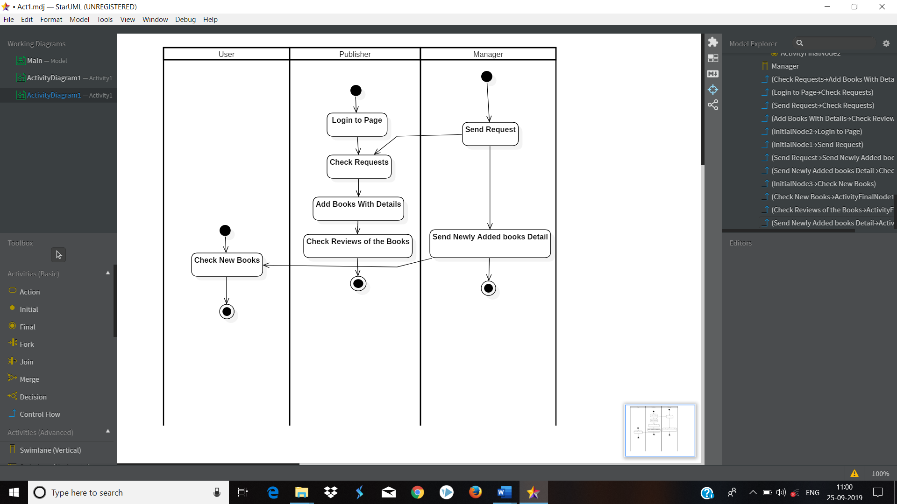

**Data Structure**

Different Data Structure are commonly use universally. Queues have variety of uses for the purpose of messaging. Stack or Heap are used. Graphs are indispensable in variety of application – Social network, mapping and geo-location application, web indexing /search.

The various data structure can be used are as follow:

1. **Dynamic :**

The size of the array will be increased when the container is full. And decreased when the container is one-quarter full.

1. **Linked:**

The container will be made up of linked list of array of fixed size. When one array is filled, a new node will be added with new array.

1. **Navigation Stack:**

A stack with additional backward and forward operation minimizing the behavior of the recording events to allow undo and redo operation.

1. **Range Stack:**

A stack that record not only the entries but also the current minimum and maximum entries in the stack. This can be implemented by having three arrays or a stack of a struct containing three entries.

1. **Dual Stack:**

One array permits two stacks, one growing from each end.

1. **Droff-off Stack:**

A stack where, if the stack is full, discards what is currently at the bottom of the stack and places the new object on the top.

**Tree Based Date Structure:**

1. AVL Tree.
2. B-Tree.
3. File System.

**Table Data Structure:**

1. Binary Heap
2. Hash Table.

**Graph Data Structure & algorithms:**

1. Dijkstra’s algorithm
2. Prim’s algorithm
3. Kruskal algorithm

**Algorithm Design:**

A data flow is graphical algorithmic tool used to describe and analyse the movement of data through a system by depicting the flow of storage of data. It defines:

1. System Process

2. Data Store

3. The Information flows in the system.

4. Any external entities that interact with the system ( System & destination of data. )

**User Interface Diagram:**

**User Pages:**

Home.aspx:

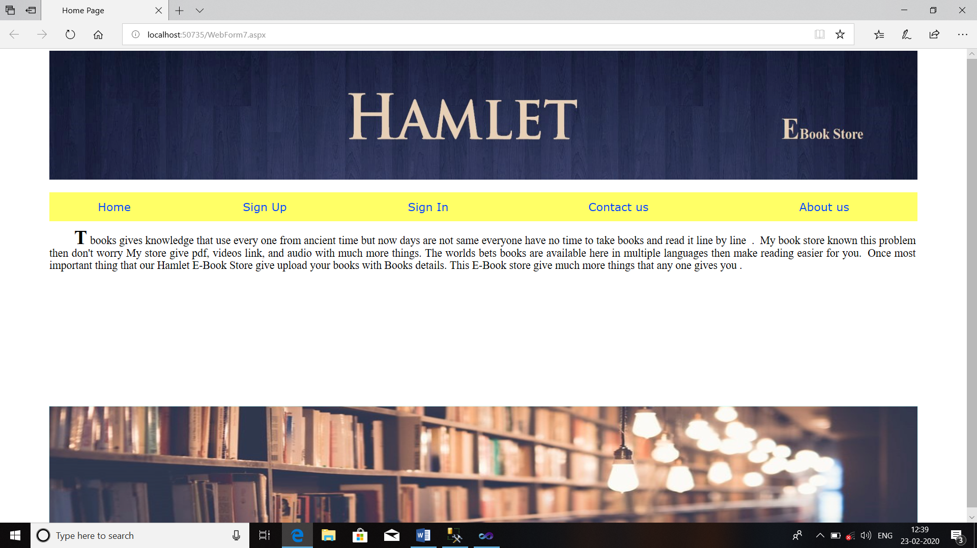

SignIn.aspx: 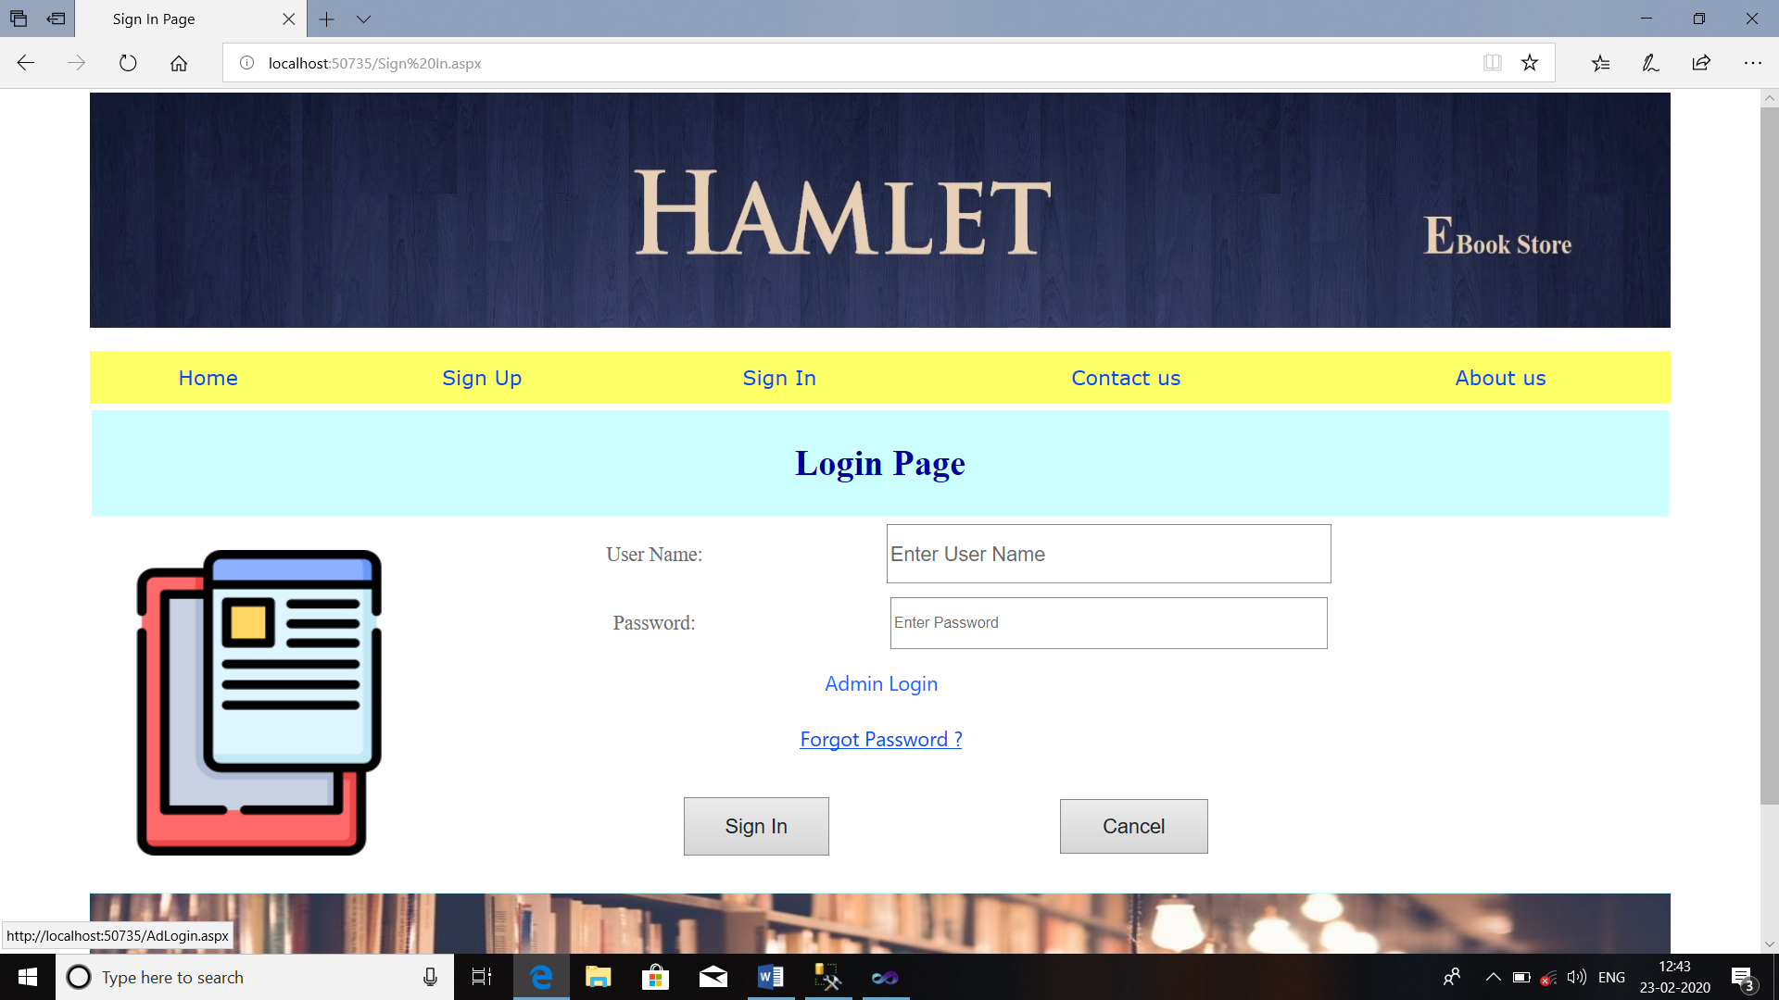

SignUp.aspx:

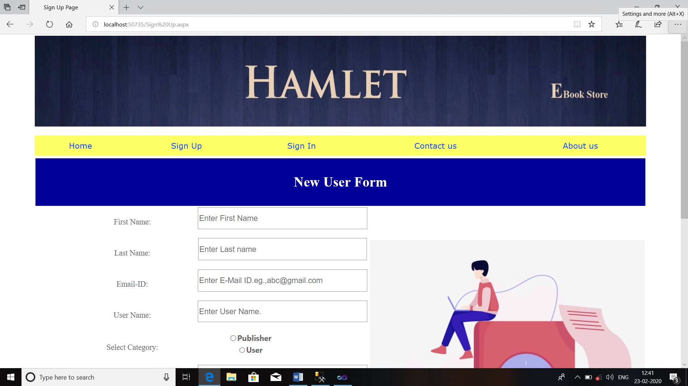

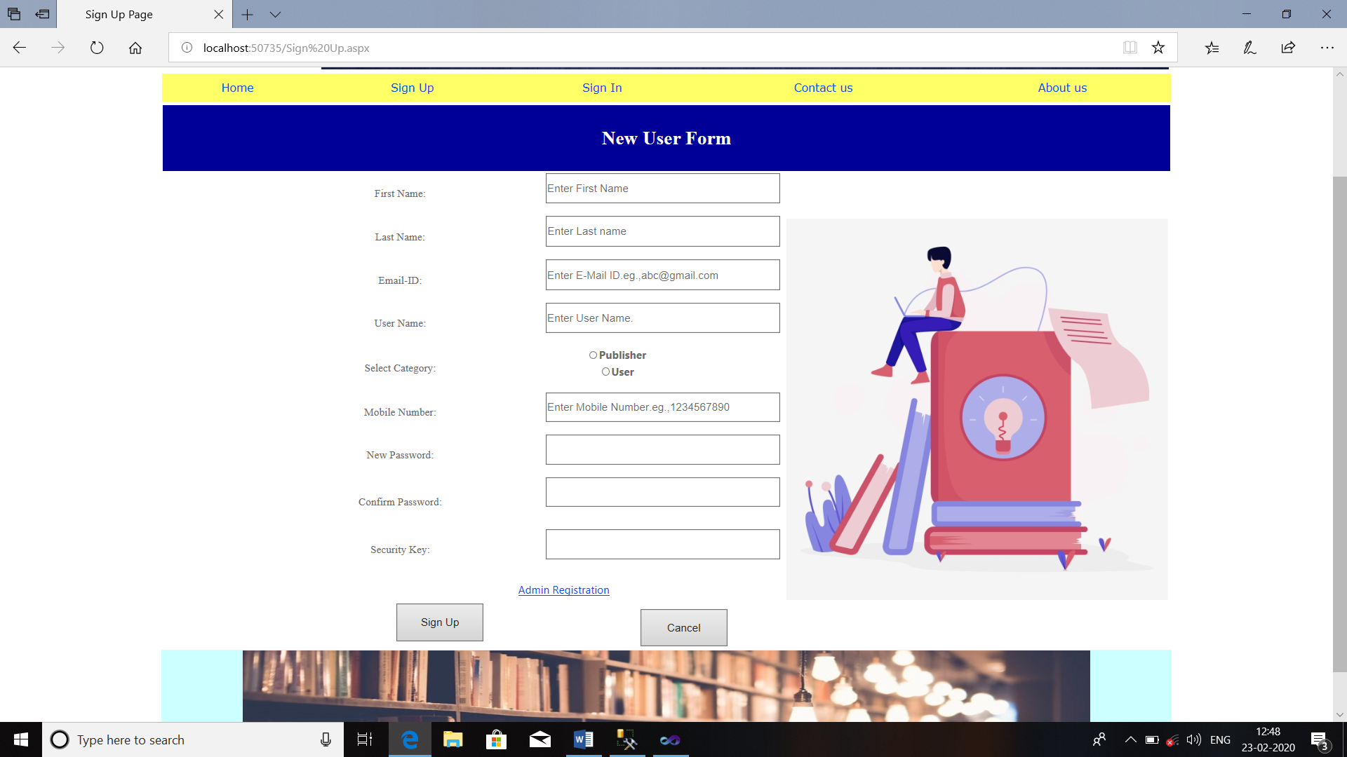

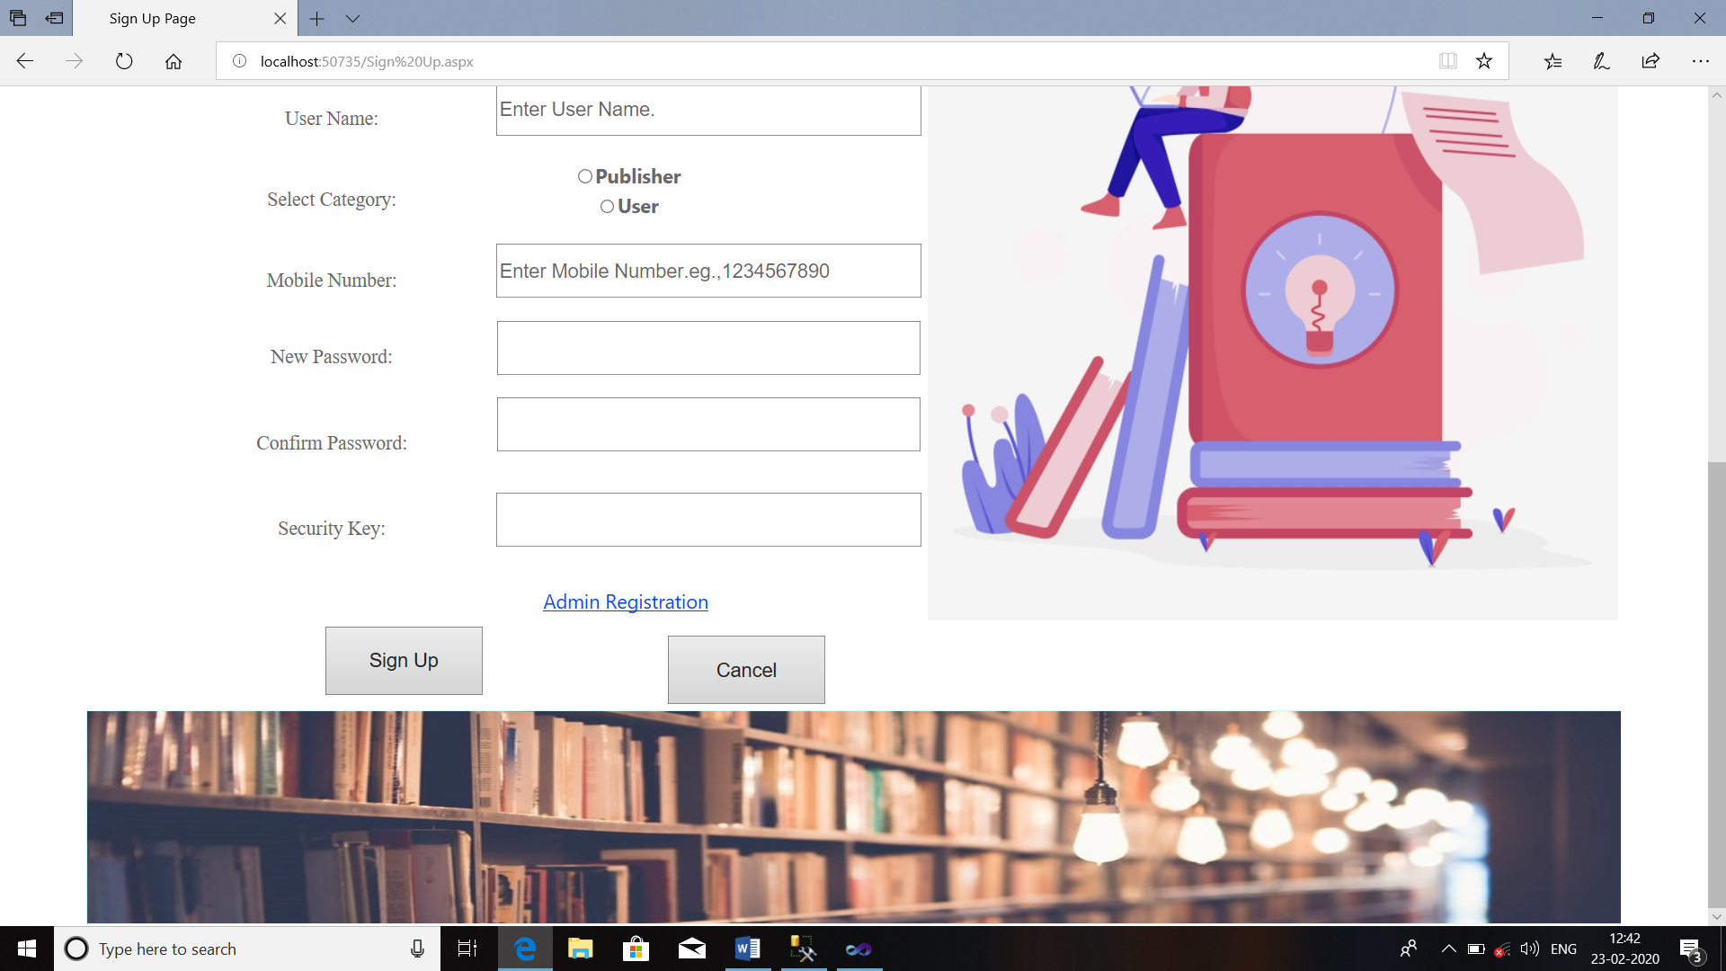

ContactUs.aspx: 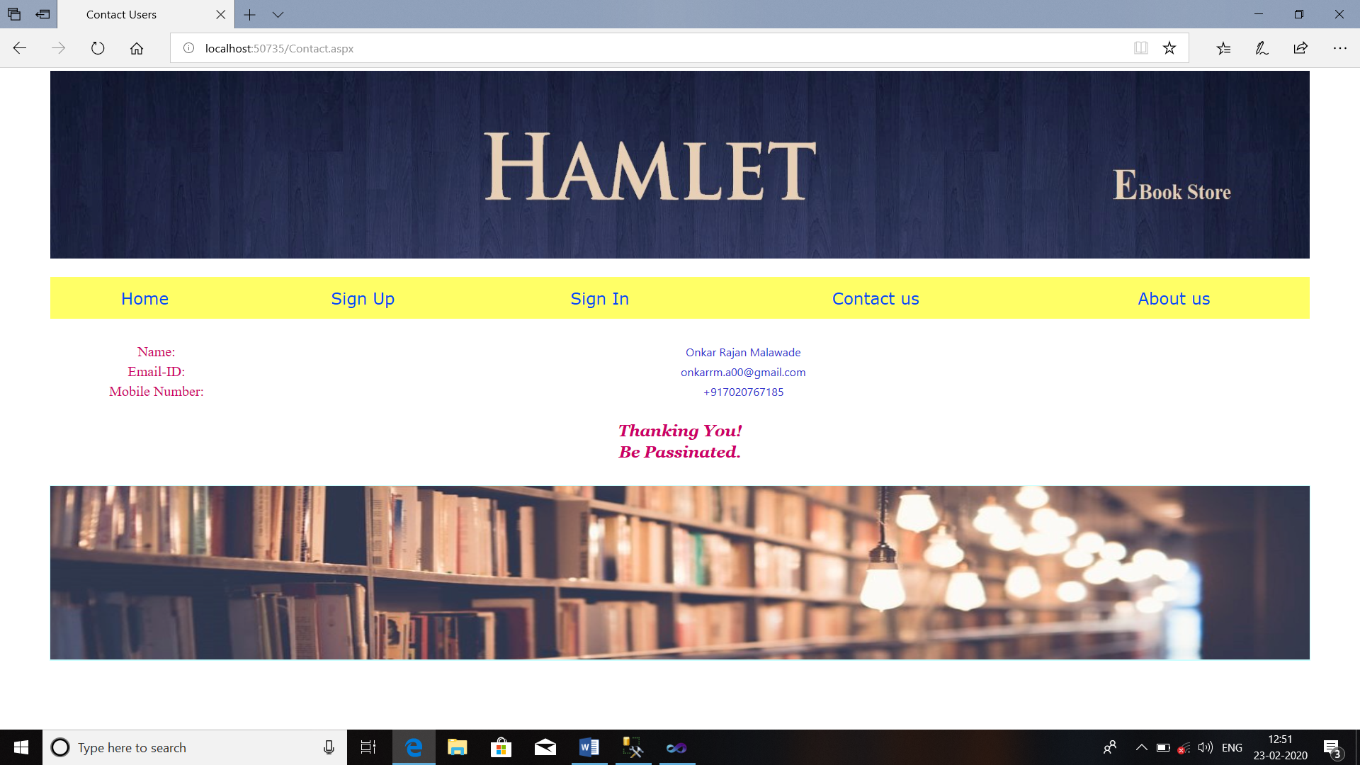

AboutUs.aspx: 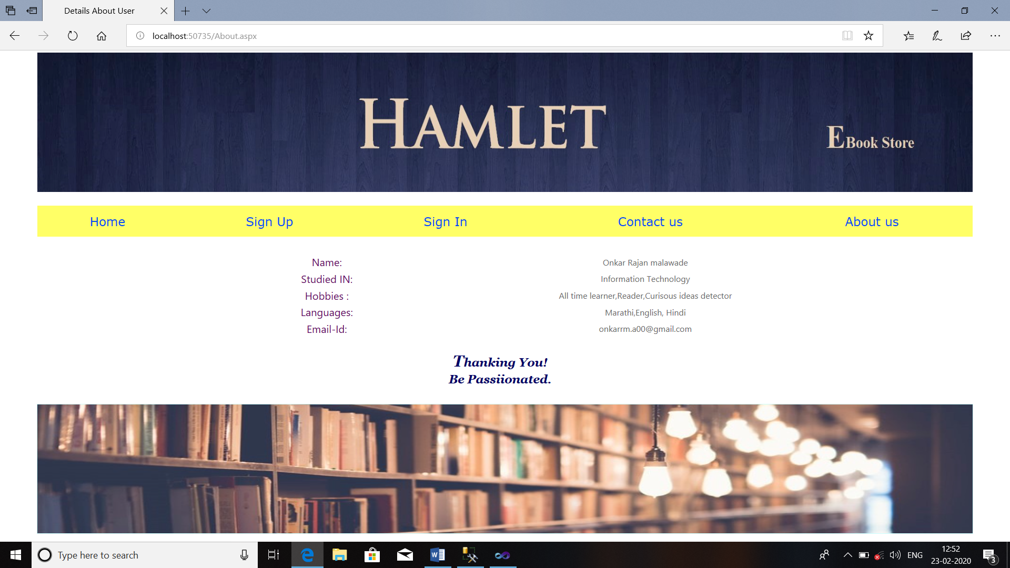

BookDetails.aspx:

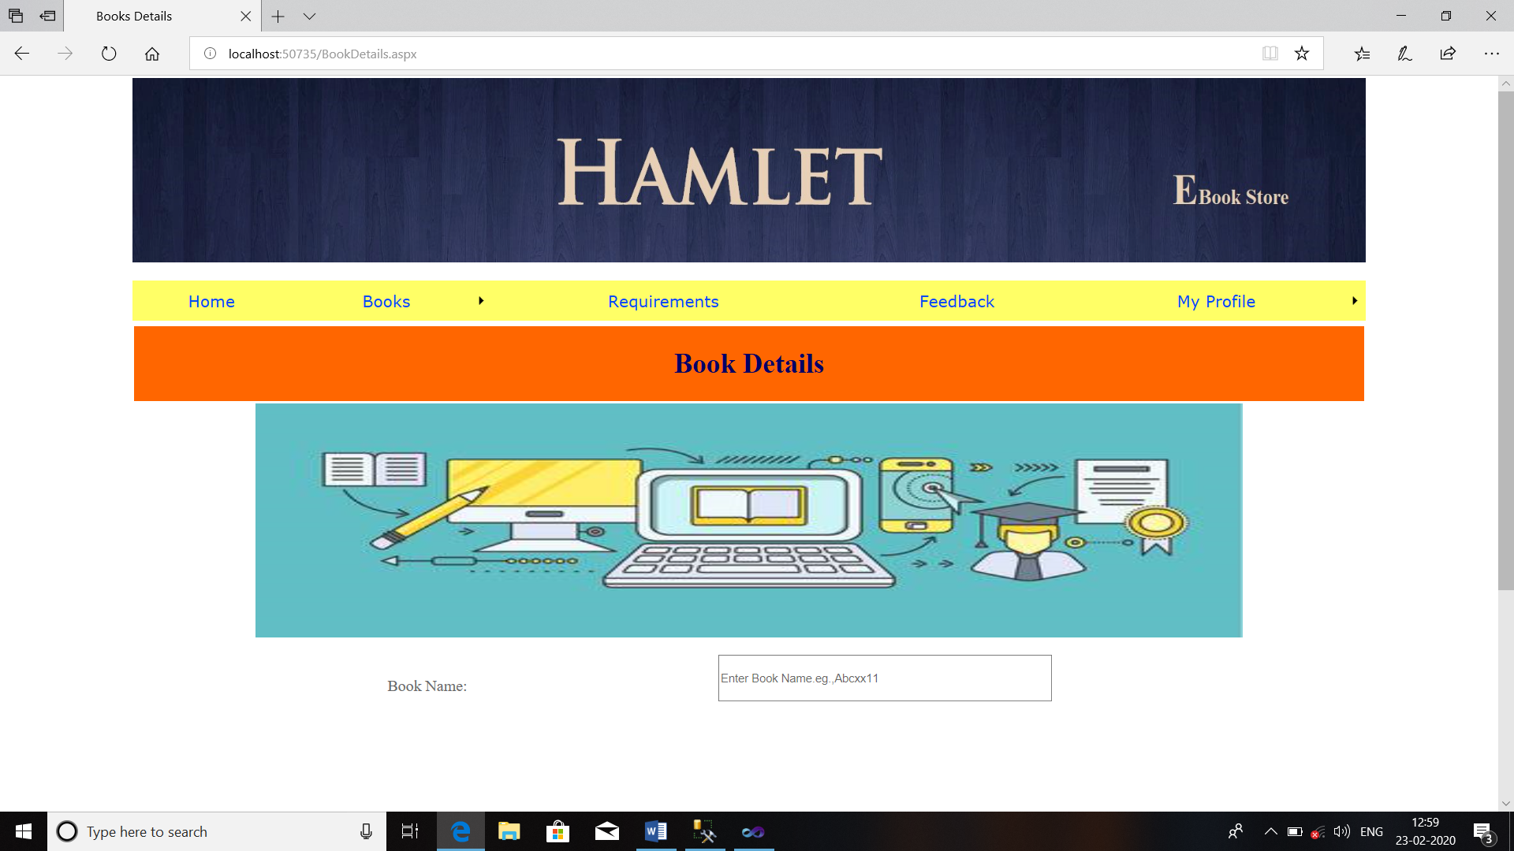

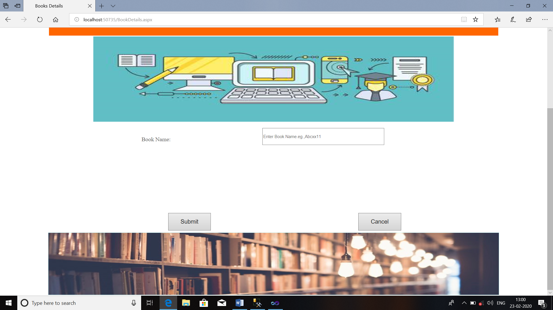

Requirements.aspx: 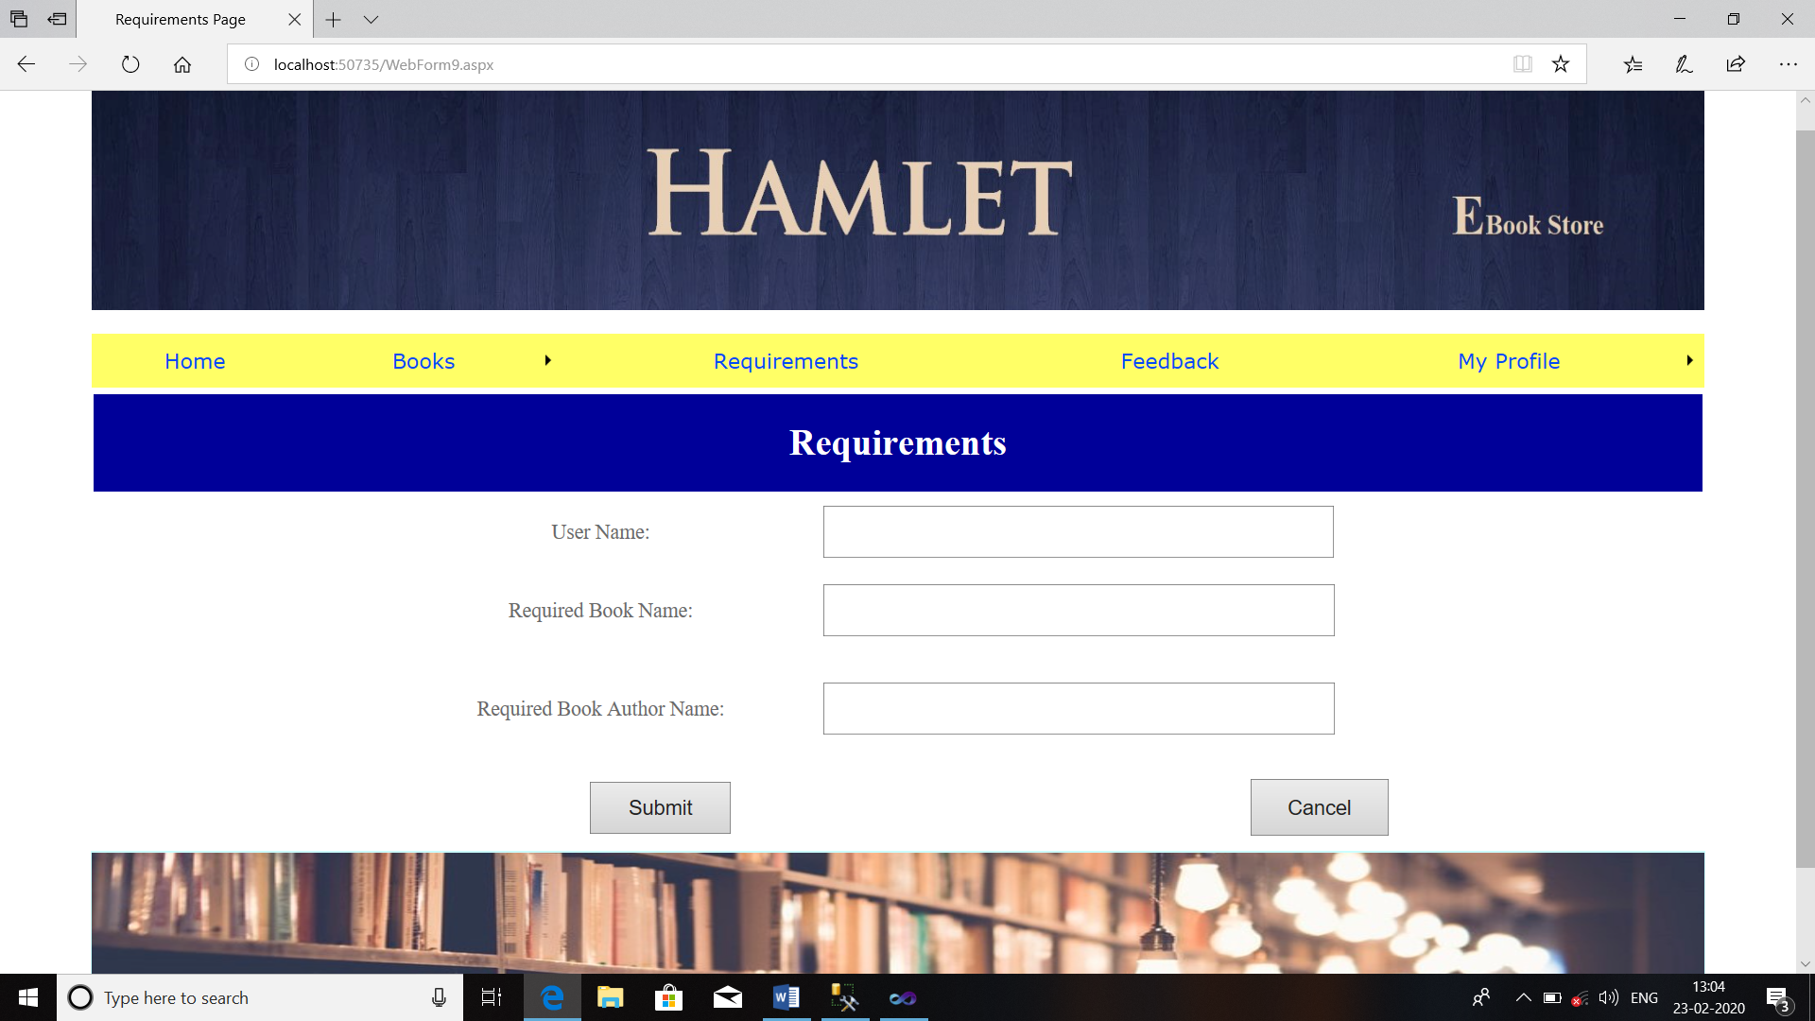

AddBooks.aspx:

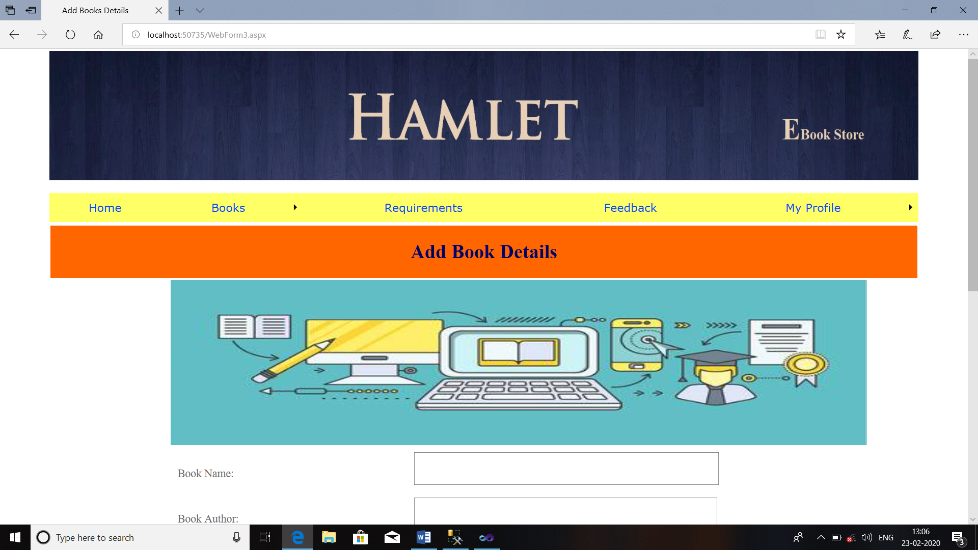

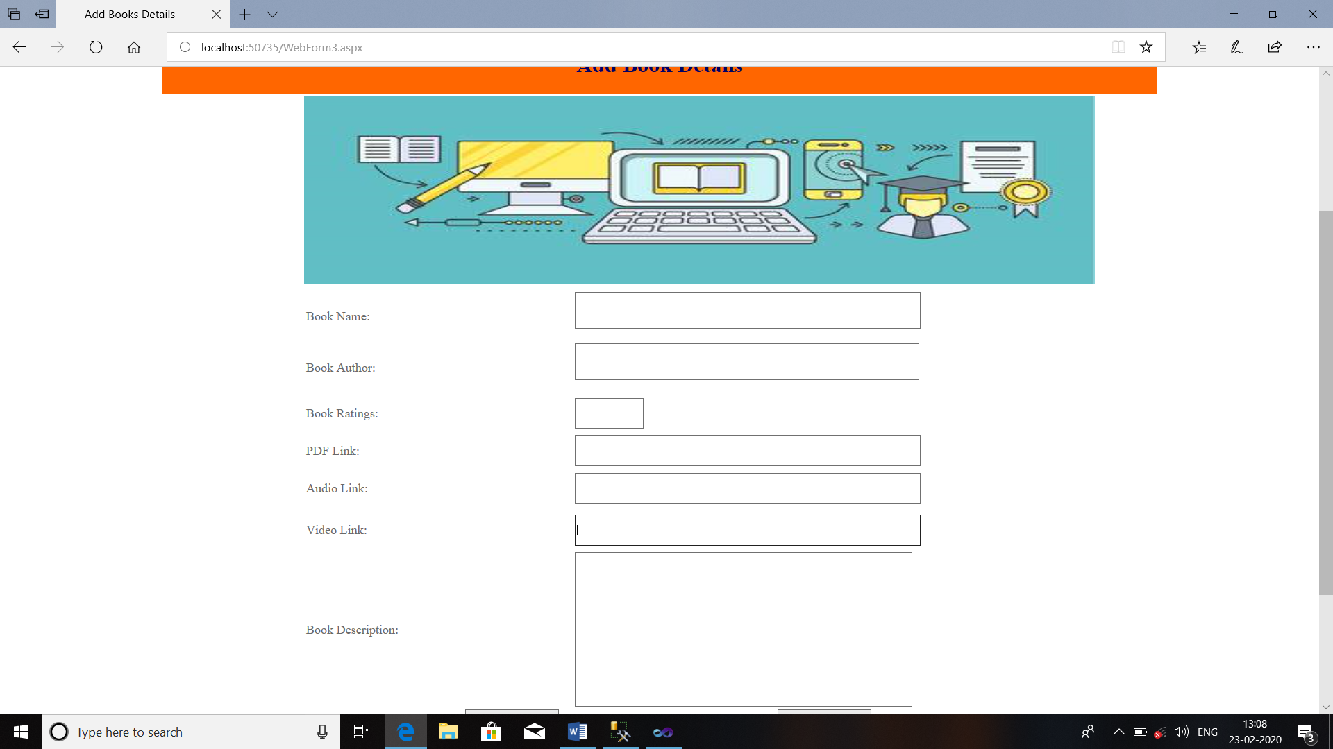

Download.aspx:

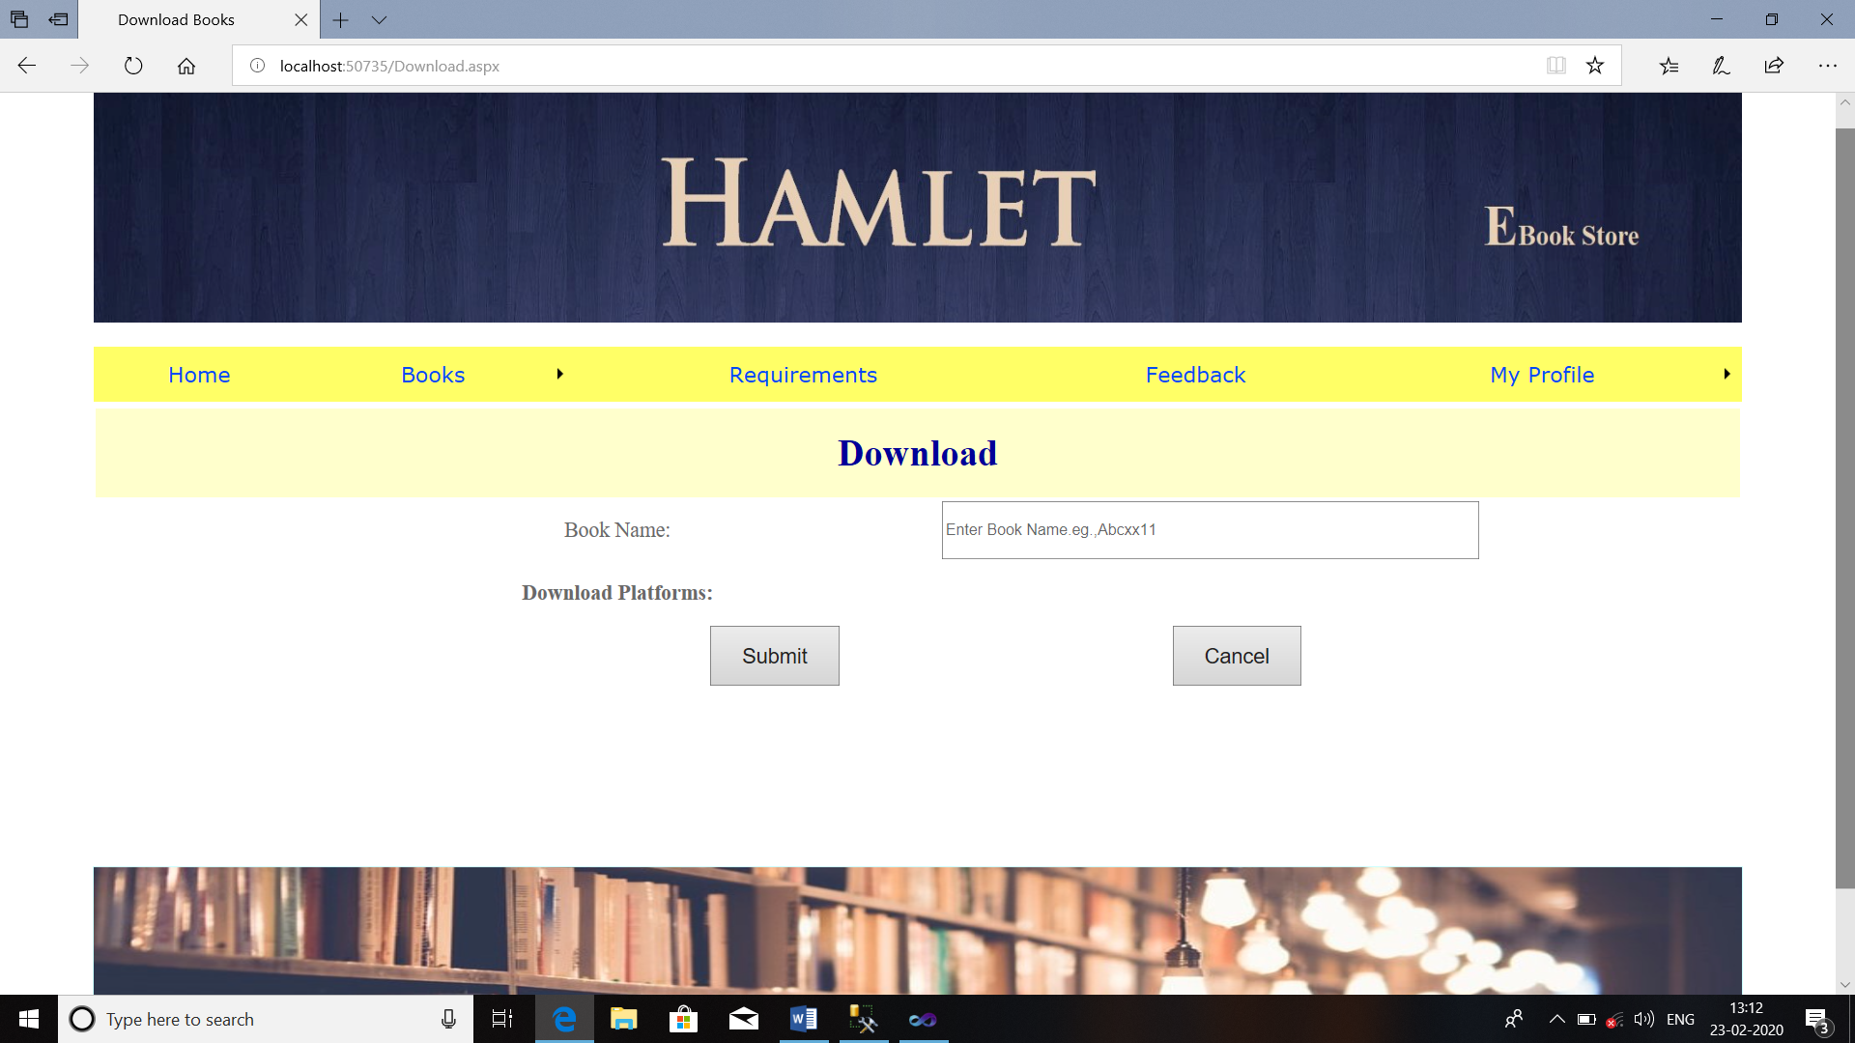

FeedBack.aspx: 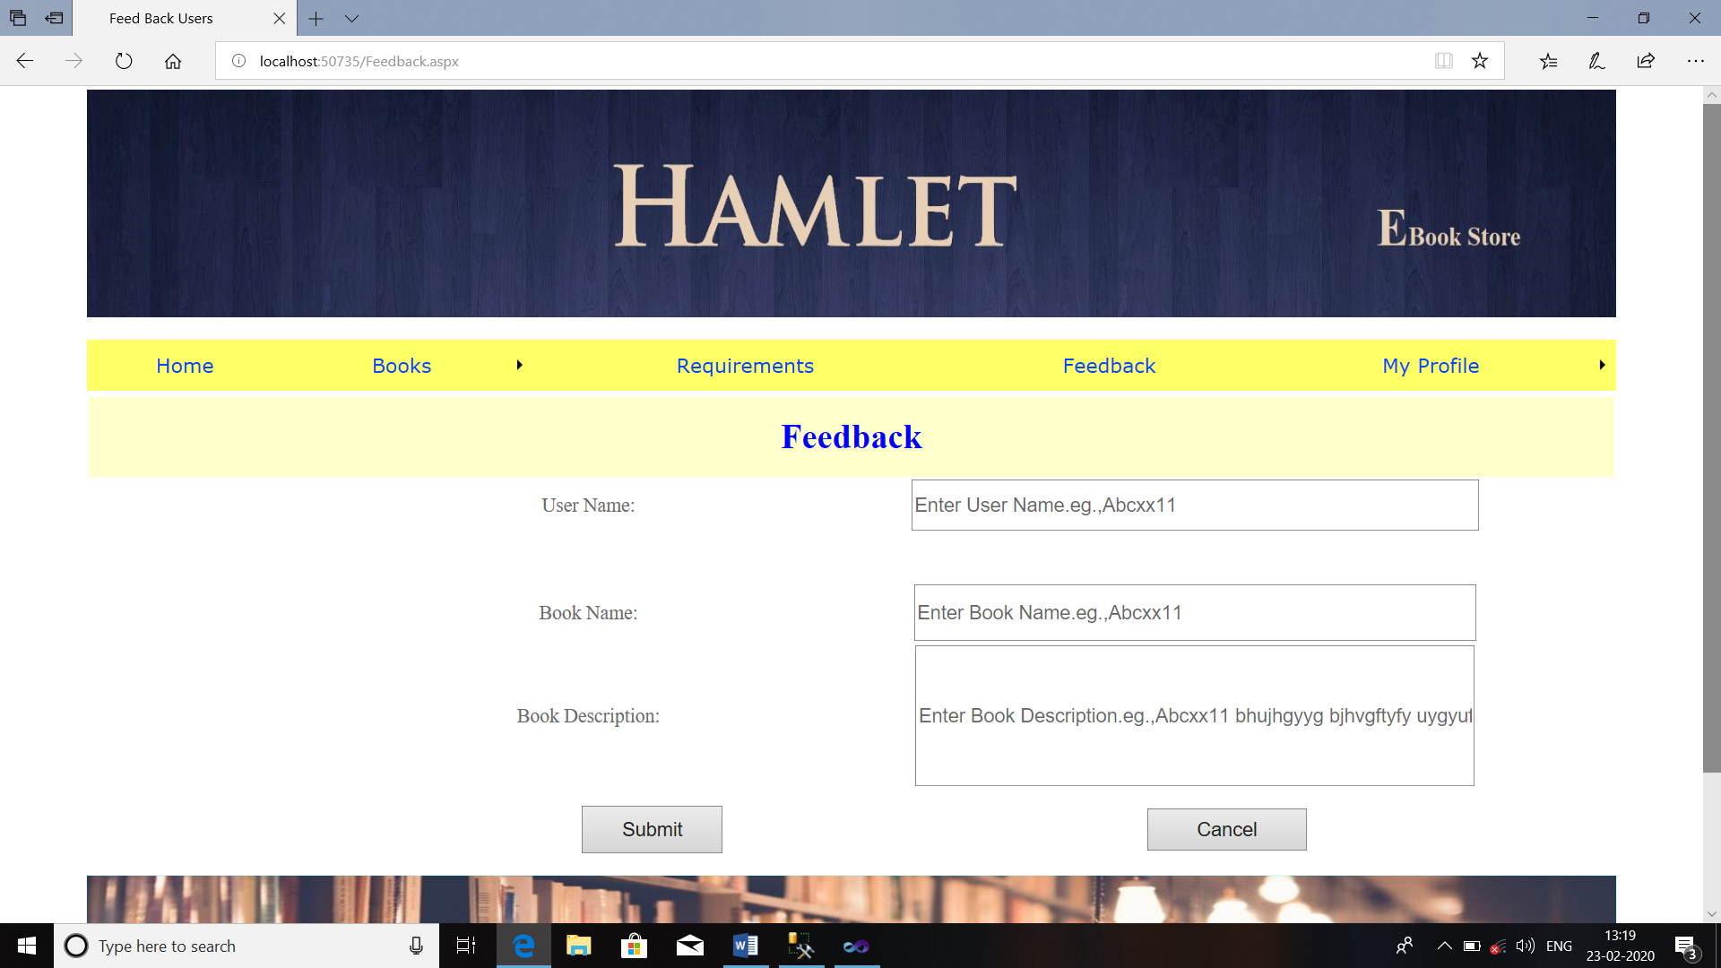

DeleteACC.aspx:

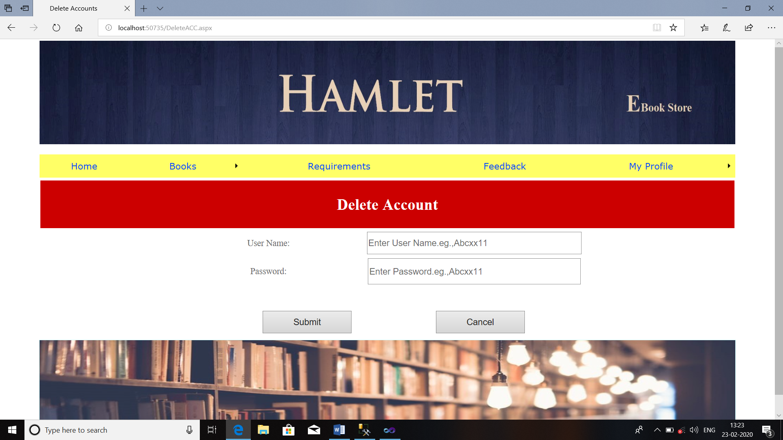

ChangePass.aspx:

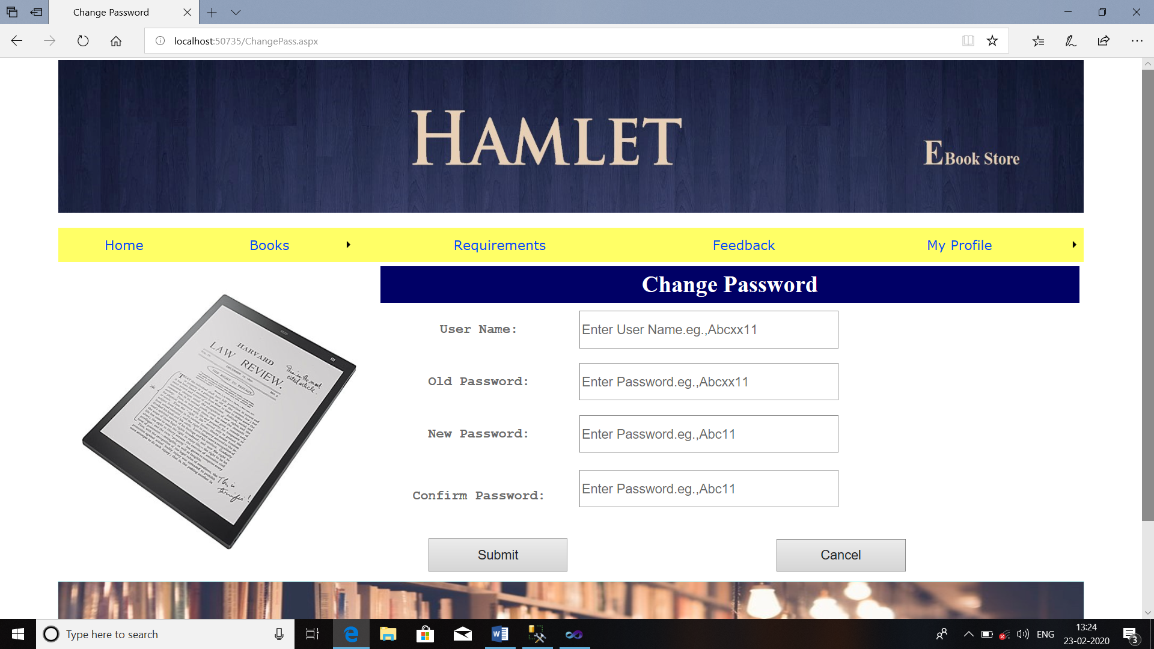

**SECURITY ISSUES**

**Most common security issues are applicable for the project:**

1. SQL Injection
2. System Failure
3. Power Cuts
4. Hardware Failure

**Test Case Design:**

|  |  |  |  |  |  |  |
| --- | --- | --- | --- | --- | --- | --- |
| **Test Case For Registration Now** | | | | | | |
| **Test Case ID** | **Test Case** | **Test Condition** | **Steps to be executed** | **Expected Result** | **Actual Result** | **Pass/Fail** |
| TC1 | New User Registration | Enter to the Web Page | 1. Click on the Web Site | E-Book Store Management open for accessing in functionality.  1)Student id(textbox)  2)Student Name(textbox)  3)Address(textbox)  4) Mobile No. (textbox)  5)Email(textbox)  6)Date Of Birth(textbox)  7)Gender(Radio buttons)  8)Course(Dropdown list)  9)Year Of Joining (textbox)  10)Year Of Pass Out (textbox)  11)Present Status(textbox)  12)Present Working Place(textbox)  13)User Name(textbox)  14)Password(textbox)  15)Confirm Password(textbox)  16)Submit(Button)  17)Cancel(Button) |  |  |
| TC2 | New User Registration | Enter to the Web Page | Try to Access Web Site | Registration Page |  |  |
| TC3 | New User Registration | Enter to Web page | Click on the Registration Form | Open the Registration Form |  |  |
| TC4 | New User Registration | Tries to fill up Registration Form | 1)Generate Student Id  2)Enter Student Name  3)Enter Address  4) Enter Mobile No.  5) Enter Email  6) Enter Date Of Birth  7) Select Gender  8)Select Course  9) Enter Year Of Joining  10) Enter Year Of Pass Out  11) Enter Present Status  12) Enter Present Working Place  13) Enter User Name  14) Enter Password  15) Retype Password  16)Click on Submit | Registration Successfully. |  |  |
| TC5 | New User Registration | Try to access cancel button functionality | Click on the Cancel Button | Cancel Successfully… |  |  |
| **Test Case For Sign In** | | | | | | |
| **Test Case ID** | **Test Case** | **Test Condition** | **Steps to be executed** | **Expected Result** | **Actual Result** | **Pass/Fail** |
| TC1 | Try to access Web Site | Enter to the Web Page | 1. Click on the Web Site | Alumni Management Portal open for accessing in functionality.  1)User Name(textbox),  2)Email ID(textbox),  3)Password(password)  4) Forgot Password?(Link)  5)Sign In(Button)  6) Cancel(Button) |  |  |
| TC2 | User Login | Enter valid User Name & Password | 1.Enter User Name in Textbox  2.Enter Email ID in Textbox  3.Enter Password in password box  4.Click on Sign In Button | User Logged in as an User |  |  |
| TC3 | User Login Test | Enter invalid User Name & Password | 1.Enter User Name in Textbox  2.Enter Email ID in Textbox  3.Enter Password in password box  4.Click on Sign In Button | Web Page should display error message: "Please enter valid User Name & Password". |  |  |
| TC4 | User Login Test | Enter valid User Name & Invalid Password | 1.Enter User Name in Textbox  2.Enter Email ID in Textbox  3.Enter Password in password box  4.Click on Sign In Button | Web Page should display error message: "Please enter valid Password". |  |  |
| TC5 | User Login Test | Enter invalid User Name & valid Password | 1.Enter User Name in Textbox  2.Enter Email ID in Textbox  3.Enter Password in password box  4.Click on Sign In Button | Web Page should display error message: "Please enter valid User Name". |  |  |

**CHAPTER-V**

**IMPLEMENTATION AND TESTING**

**UserMasterPage.Master:**

<%@ Master Language="C#" AutoEventWireup="true" CodeFile="Site3.master.cs" Inherits="HomePage1.Site3" %>

<!DOCTYPE html PUBLIC "-//W3C//DTD XHTML 1.0 Transitional//EN" "http://www.w3.org/TR/xhtml1/DTD/xhtml1-transitional.dtd">

<html xmlns="http://www.w3.org/1999/xhtml">

<head id="Head1" runat="server">

<title></title>

<link href="~/Styles/Site.css" rel="stylesheet" type="text/css" />

<style type="text/css">

.style1

{

width: 76%;

height: 477px;

margin-right: 0px;

}

.style2

{

width: 1422px;

height: 212px;

text-align: center;

margin-left: 0px;

background-color: #FFFFFF;

}

.style4

{

height: 194px;

width: 1009px;

text-align: right;

}

.style6

{

width: 1009px;

background-color: #CCFFFF;

}

.style10

{

background-color: #FFFFFF;

}

.style11

{

margin-left: 0px;

}

.style12

{

color: #FFFFFF;

}

.style13

{

font-size: medium;

color: #000000;

}

.style14

{

font-family: "Times New Roman", Times, serif;

}

</style>

</head>

<body bgcolor="white">

<form id="form1" runat="server">

<div>

<table class="style1" align="center">

<tr>

<td class="style4">

<img alt="header" class="style2" src="Image/header.jpg" align="center"/>&nbsp; </td>

</tr>

<tr>

<td class="style10">

<asp:Menu ID="Menu2" runat="server" BackColor="#B5C7DE"

DynamicHorizontalOffset="2" Font-Names="Verdana" Font-Size="1.2em"

ForeColor="#284E98" Height="47px" Orientation="Horizontal"

RenderingMode="Table" StaticSubMenuIndent="15px"

style="background-color: #FFFF66; text-align: center; font-family: Arial, Helvetica, sans-serif;"

Width="100%" CssClass="style11">

<DynamicHoverStyle BackColor="#284E98" ForeColor="White" />

<DynamicMenuItemStyle HorizontalPadding="5px" VerticalPadding="2px" />

<DynamicMenuStyle BackColor="#B5C7DE" />

<DynamicSelectedStyle BackColor="#507CD1" />

<Items>

<asp:MenuItem Text="Home" Value="Home" NavigateUrl="~/WebForm17.aspx"></asp:MenuItem>

<asp:MenuItem Text="Books" Value="Books" >

<asp:MenuItem Text="Books Details" Value="Books Details"

NavigateUrl="~/BookDetails.aspx"></asp:MenuItem>

<asp:MenuItem Text="Add Books" Value="Books Details"

NavigateUrl="~/AddBK.aspx"></asp:MenuItem>

<asp:MenuItem Text="Download Books" Value="Download Books"

NavigateUrl="~/Download.aspx"></asp:MenuItem>

</asp:MenuItem>

<asp:MenuItem Text="Requirements" Value="Requirements"

NavigateUrl="~/WebForm9.aspx"></asp:MenuItem>

<asp:MenuItem Text="Feedback" Value="Feedback" NavigateUrl="~/Feedback.aspx"></asp:MenuItem>

<asp:MenuItem Text="My Profile" Value="My Profile">

<asp:MenuItem Text="Delete Account" Value="Delete" NavigateUrl="~/DeleteACC.aspx"></asp:MenuItem>

<asp:MenuItem Text="Change Password" Value="Change Password" NavigateUrl="~/ChangePass.aspx"></asp:MenuItem>

<asp:MenuItem Text="Log Out" Value="Log Out" NavigateUrl="~/WebForm7.aspx"></asp:MenuItem>

</asp:MenuItem>

</Items>

<StaticHoverStyle BackColor="#284E98" ForeColor="White" />

<StaticMenuItemStyle HorizontalPadding="5px" VerticalPadding="2px" />

<StaticSelectedStyle BackColor="#507CD1" />

</asp:Menu>

</td></tr>

<tr>

<td>

<asp:ContentPlaceHolder ID="Main" runat="server">

</asp:ContentPlaceHolder>

</td>

</tr>

<tr>

<td class="style6">

<asp:Panel ID="Panel2" runat="server"

BackImageUrl="~/Image/footer of mainPanel.jpg" Height="299px" Width="1424px">

<span class="style14"><span class="style13">

<br />

<br />

<br />

<br />

<br class="style12" />

</span><span class="style12"><span class="style13">All Rights reserved at @ VVD

Talere,<br /> Site Design and Developed By : Onkar Rajan Malawade T.Y.B.Sc.IT

2019-2020,<br /> Maintained by Department of IT &amp; IT of VVD Talere.</span></span></span></asp:Panel></td>

</tr>

</table>

</div>

</form>

</body>

</html>

**Sign In.aspx:**

<%@ Page Title="Sign In Page" Language="C#" MasterPageFile="~/Site2.Master" AutoEventWireup="true" CodeFile="WebForm1.aspx.cs" Inherits="HomePage1.WebForm1" %>

<asp:Content ID="Content1" ContentPlaceHolderID="Main" runat="server">

<table style="width: 100%; height: 433px;">

<tr>

<td style="font-family: 'Times New Roman', Times, serif; font-size: xx-large; text-align: center; height: 81px; color: #000099; background-color: #CCFFFF;"

colspan="4">

<strong>Login Page</strong></td>

</tr>

<tr>

<td style="width: 298px; " rowspan="5">

<img alt="EBOOK" src="Image/ebook.png" style="width: 291px; height: 275px" /></td>

<td class="style10"

style="width: 406px; font-family: 'Times New Roman', Times, serif; height: 30px; font-size: large">

User Name:</td>

<td class="style10" style="width: 404px; height: 30px">

<asp:TextBox ID="uname" runat="server" Height="47px" Width="396px"

style="font-size: large" placeholder="Enter User Name"></asp:TextBox>

</td>

<td style="height: 30px">

<asp:RequiredFieldValidator ID="RequiredFieldValidator1" runat="server"

ControlToValidate="uname" ErrorMessage="Enter User Name!"></asp:RequiredFieldValidator>

</td>

</tr>

<tr>

<td style="width: 406px; height: 31px; font-family: 'Times New Roman', Times, serif; font-size: large">

Password:</td>

<td style="width: 404px; height: 31px">

<asp:TextBox ID="cpass" runat="server" Height="41px" Width="389px" TextMode="Password" placeholder="Enter Password"></asp:TextBox>

</td>

<td style="height: 31px">

<asp:RequiredFieldValidator ID="RequiredFieldValidator2" runat="server"

ControlToValidate="cpass" ErrorMessage="Enter Correct Password!!!"></asp:RequiredFieldValidator>

</td>

</tr>

<tr>

<td colspan="2" style="text-align: center; height: 39px">

<asp:HyperLink ID="HyperLink2" runat="server" style="font-size: large"

NavigateUrl="~/AdLogin.aspx">Admin Login</asp:HyperLink>

</td>

<td style="height: 39px">

&nbsp;</td>

</tr>

<tr>

<td colspan="2" style="text-align: center; height: 39px">

<asp:HyperLink ID="HyperLink1" runat="server" style="font-size: large"

NavigateUrl="~/Forgot.aspx">Forgot Password ?</asp:HyperLink>

</td>

<td style="height: 39px">

</td>

</tr>

<tr>

<td style="width: 406px; height: 92px;">

<span style="font-size: large">&nbsp;&nbsp;&nbsp;&nbsp;&nbsp;&nbsp;&nbsp;&nbsp;&nbsp;&nbsp;&nbsp;&nbsp;&nbsp;&nbsp;&nbsp;&nbsp;&nbsp;&nbsp;&nbsp;&nbsp;&nbsp;&nbsp;&nbsp;&nbsp;&nbsp;&nbsp;&nbsp;&nbsp;&nbsp;&nbsp;&nbsp;&nbsp;&nbsp; &nbsp;&nbsp;

</span>

<asp:Button ID="Button1" runat="server" Height="52px" Text="Sign In"

Width="131px" style="font-size: large" onclick="Button1_Click" />

</td>

<td style="width: 404px; height: 92px;">

<span style="font-size: large">&nbsp;&nbsp;&nbsp;&nbsp;&nbsp;&nbsp;&nbsp;&nbsp;

</span>

<asp:Button ID="Button2" runat="server" Height="49px"

Text="Cancel" Width="133px" style="font-size: large"

onclick="Button2_Click" />

</td>

<td style="height: 92px">

&nbsp;</td>

</tr>

</table>

</asp:Content>

**Sign In.aspx.cs:**

using System;

using System.Collections.Generic;

using System.Linq;

using System.Web;

using System.Web.UI;

using System.Web.UI.WebControls;

using System.Data.SqlClient;

using System.Data;

using System.Configuration;

using System.Data.Sql;

namespace HomePage1

{

public partial class WebForm1 : System.Web.UI.Page

{

SqlConnection con;

SqlCommand cmd;

protected void Page_Load(object sender, EventArgs e)

{

String path = "Data Source=LAPTOP-6O8VDLBU\\SQLEXPRESS;Initial Catalog=ebookdb;Integrated Security=True";

con = new SqlConnection();

con.ConnectionString = path;

con.Open();

}

protected void Button1_Click(object sender, EventArgs e)

{

cmd = new SqlCommand("select * from RegDB where uname =@uname and cpass=@cpass", con);

cmd.Parameters.AddWithValue("@uname", uname.Text);

cmd.Parameters.AddWithValue("@cpass", cpass.Text);

SqlDataAdapter da = new SqlDataAdapter(cmd);

DataTable dt = new DataTable();

da.Fill(dt);

if (dt.Rows.Count > 0)

{

Response.Redirect("WebForm17.aspx");

}

else

{

ClientScript.RegisterStartupScript(Page.GetType(), "validation", "<script language='javascript'>alert('Invalid Username and Password')</script>");

}

con.Close();

}

protected void Button2_Click(object sender, EventArgs e)

{

uname.Text = string.Empty;

cpass.Text = string.Empty;

}

}

}

**UNIT TESTING:**

**UNIT TESTING** is a level of software testing where individual units/ components of a software are tested. The purpose is to validate that each unit of the software performs as designed. A unit is the smallest testable part of any software. It usually has one or a few inputs and usually a single output. In procedural programming, a unit may be an individual program, function, procedure, etc. In object-oriented programming, the smallest unit is a method, which may belong to a base/ super class, abstract class or derived/ child class. (Some treat a module of an application as a unit. This is to be discouraged as there will probably be many individual units within that module.) Unit testing frameworks, drivers, stubs, and mock/ fake objects are used to assist in unit testing.

**INTEGRATION TESTING:**

**INTEGRATION TESTING** is a level of software testing where individual units are combined and tested as a group. The purpose of this level of testing is to expose faults in the interaction between integrated units. Test drivers and test stubs are used to assist in Integration Testing.

**SYSTEM TESTING:**

**SYSTEM TESTING** is the testing of a complete and fully integrated web product.

Usually website is only one element of a larger web based system. Ultimately, software is interfaced with other software/hardware systems.

System Testing is actually a series of different tests whose sole purpose is to exercise the full web based system.

**NON-FUNCTIONAL TESTING:**

### **Performance Testing:**

First and foremost type of non-functional testing is performance testing. In order to ensure that the response time of a system is acceptable, performance testing is carried out. By setting up a considerable load and a production-sized database, the system is tested for response times of several business critical processes.

### **Load Testing:**

Types of non functional testing in software testing also includes load testing. To check whether the system can sustain the pressure or load of many users accessing the system at one time, load testing needs to be carried out. The production load is replicated in the test environment in this case after which the application/system is tested.

### **Stress Testing:**

This testing is done to pull the system far beyond its capabilities and see how it reacts. Contrary to load testing in which the maximum allowable load is generated, in stress testing, the load generated is more than what the system is expected to handle.

### **Security Testing:**

While performing non-functional testing, to test how well the system can preserve itself and the data it holds in situation of malicious attacks is called security testing. Confidentiality, integrity, availability, authentication and authorization are the main areas that are tested when security testing is considered. Also, network security, system security and application security are other areas that will be tested in this case.

### **Usability Testing :**

To verify the ease of usage of an interface within an application is what usability testing is about. Learnability and memorability of the application are main factors in this case. This testing is particularly important when testing GUI.

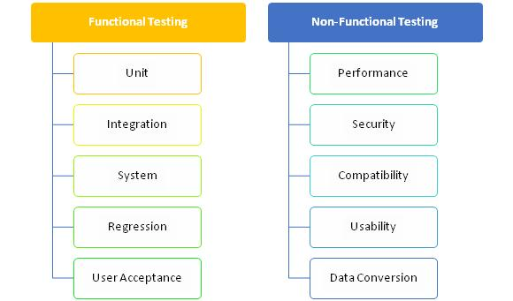

|  |  |  |  |  |  |  |  |
| --- | --- | --- | --- | --- | --- | --- | --- |
| **Test Case For Registration Now** | | | | | | | |
| **Test Case ID** | **Test Case** | **Test Condition** | **Steps to be executed** | **Expected Result** | **Actual Result** | **Pass/Fail** | **Comment** |
| TC1 | New User Registration | Enter to the Web Page | 1. Click on the Web Site | E-Book Store Management open for accessing in functionality.  1)Student id(textbox)  2)Student Name(textbox)  3)Address(textbox)  4) Mobile No. (textbox)  5)Email(textbox)  6)Date Of Birth(textbox)  7)Gender(Radio buttons)  8)Course(Dropdown list)  9)Year Of Joining (textbox)  10)Year Of Pass Out (textbox)  11)Present Status(textbox)  12)Present Working Place(textbox)  13)User Name(textbox)  14)Password(textbox)  15)Confirm Password(textbox)  16)Submit(Button)  17)Cancel(Button) | As Expected | Pass |  |
| TC2 | New User Registration | Enter to the Web Page | Try to Access Web Site | Registration Page | As Expected | Pass |  |
| TC3 | New User Registration | Enter to Web page | Click on the Registration Form | Open the Registration Form | As Expected | Pass |  |
| TC4 | New User Registration | Tries to fill up Registration Form | 1)Generate Student Id  2)Enter Student Name  3)Enter Address  4) Enter Mobile No.  5) Enter Email  6) Enter Date Of Birth  7) Select Gender  8)Select Course  9) Enter Year Of Joining  10) Enter Year Of Pass Out  11) Enter Present Status  12) Enter Present Working Place  13) Enter User Name  14) Enter Password  15) Retype Password  16)Click on Submit | Registration Successfully. | As Expected | Pass |  |
| TC5 | New User Registration | Try to access cancel button functionality | Click on the Cancel Button | Cancel Successfully… | As Expected | Pass |  |
| **Test Case For Sign In** | | | | | | | |
| **Test Case ID** | **Test Case** | **Test Condition** | **Steps to be executed** | **Expected Result** | **Actual Result** | **Pass/Fail** | **Comment** |
| TC1 | Try to access Web Site | Enter to the Web Page | 1. Click on the Web Site | Alumni Management Portal open for accessing in functionality.  1)User Name(textbox),  2)Email ID(textbox),  3)Password(password)  4) Forgot Password?(Link)  5)Sign In(Button)  6) Cancel(Button) | As Expected | Pass |  |
| TC2 | User Login | Enter valid User Name & Password | 1.Enter User Name in Textbox  2.Enter Email ID in Textbox  3.Enter Password in password box  4.Click on Sign In Button | User Logged in as an User | As Expected | Pass |  |
| TC3 | User Login Test | Enter invalid User Name & Password | 1.Enter User Name in Textbox  2.Enter Email ID in Textbox  3.Enter Password in password box  4.Click on Sign In Button | Web Page should display error message: "Please enter valid User Name & Password". | As Expected | Pass |  |
| TC4 | User Login Test | Enter valid User Name & Invalid Password | 1.Enter User Name in Textbox  2.Enter Email ID in Textbox  3.Enter Password in password box  4.Click on Sign In Button | Web Page should display error message: "Please enter valid Password". | As Expected | Pass |  |
| TC5 | User Login Test | Enter invalid User Name & valid Password | 1.Enter User Name in Textbox  2.Enter Email ID in Textbox  3.Enter Password in password box  4.Click on Sign In Button | Web Page should display error message: "Please enter valid User Name". | As Expected | Pass |  |

**CHAPTER-VII**

**RESULTS & DISCUSSION**

**Reports:**

User Report:

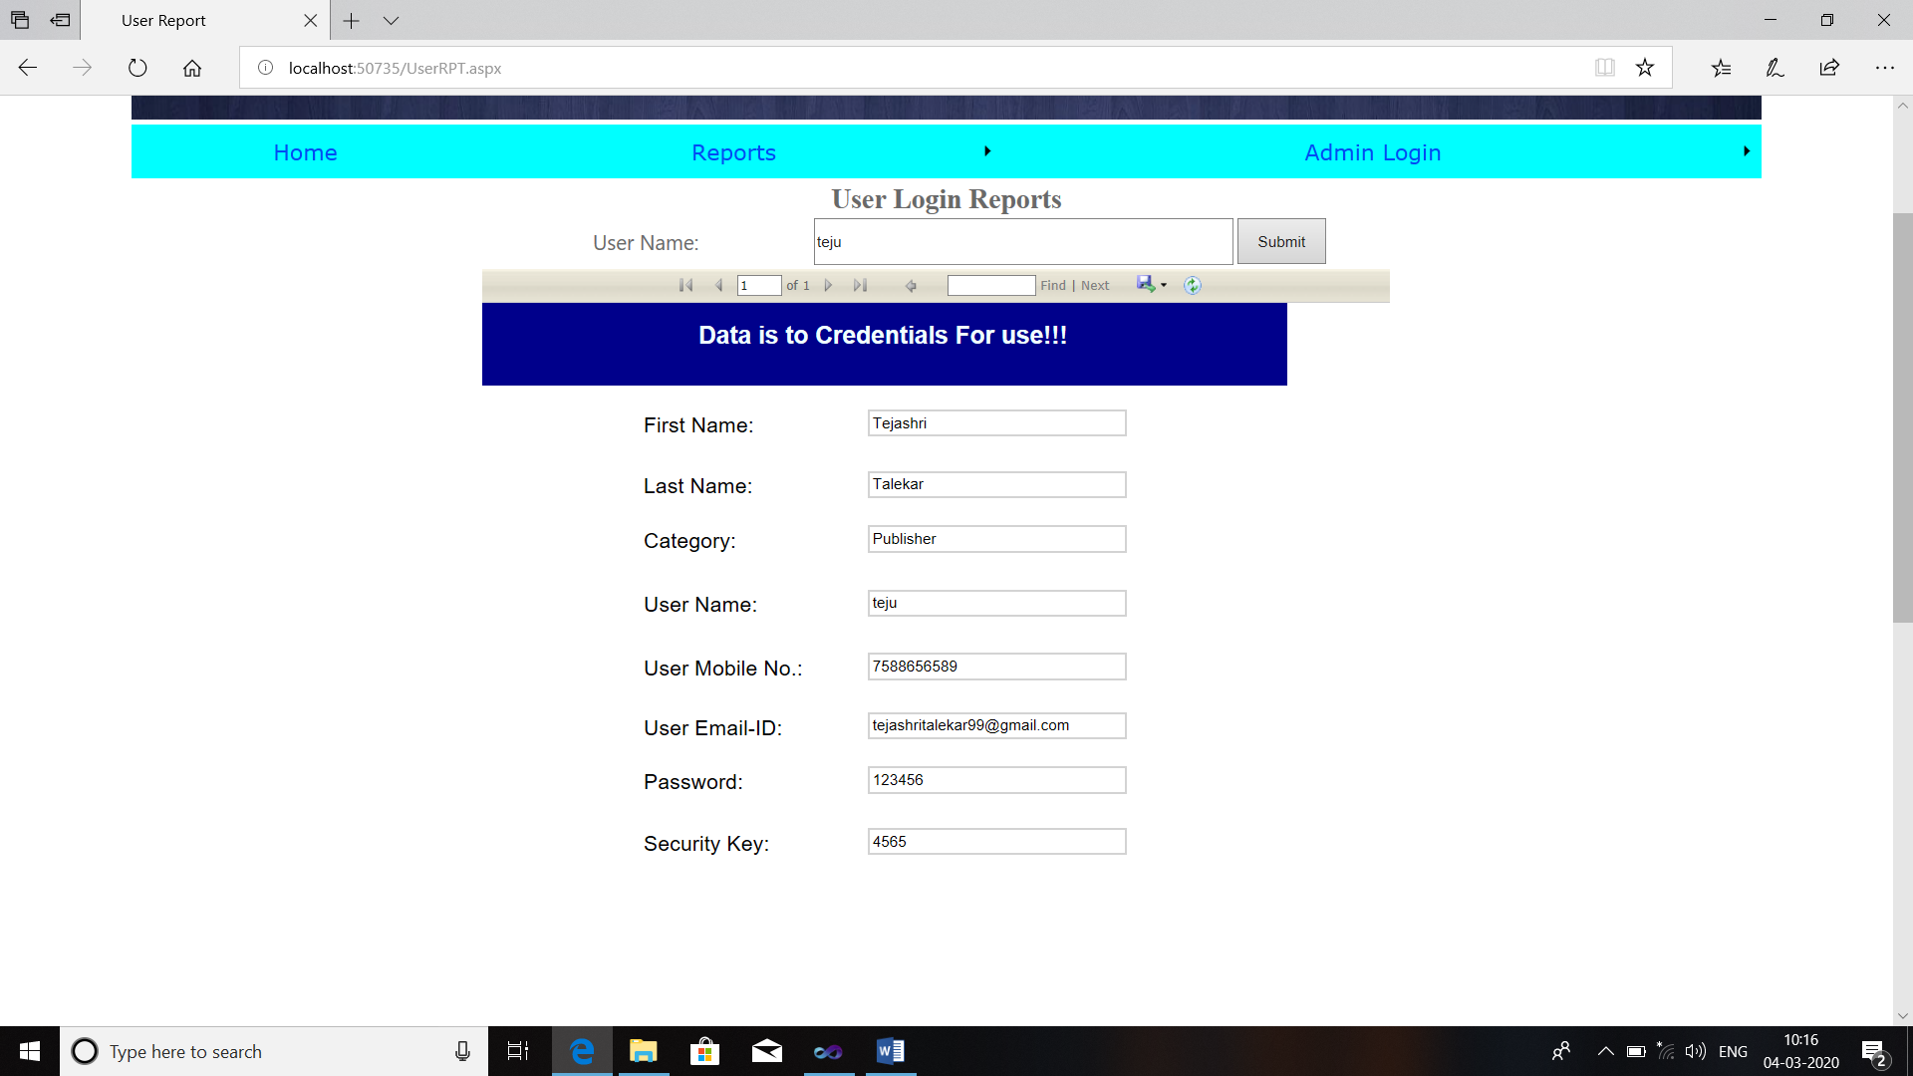

Admin Report:

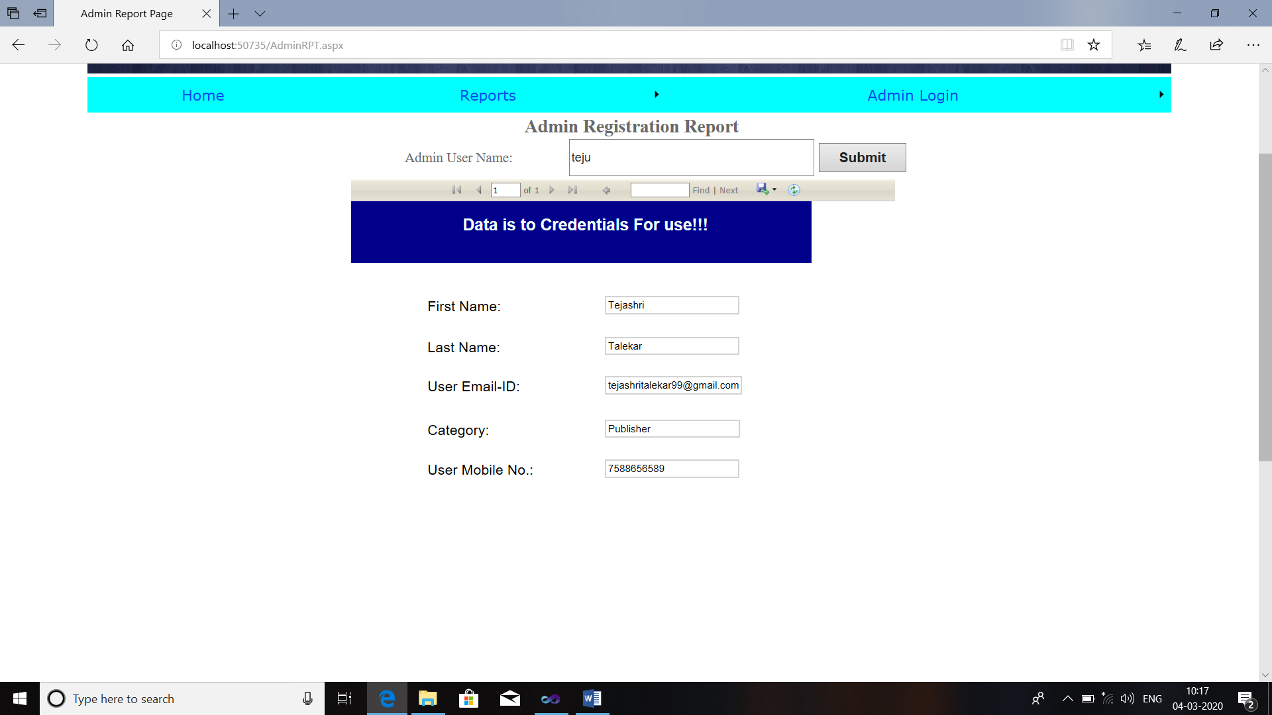

Books Report:

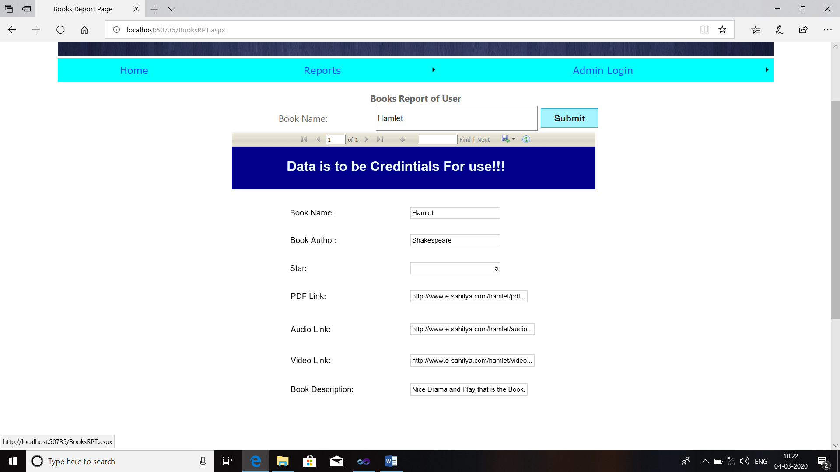

Feedback Report:

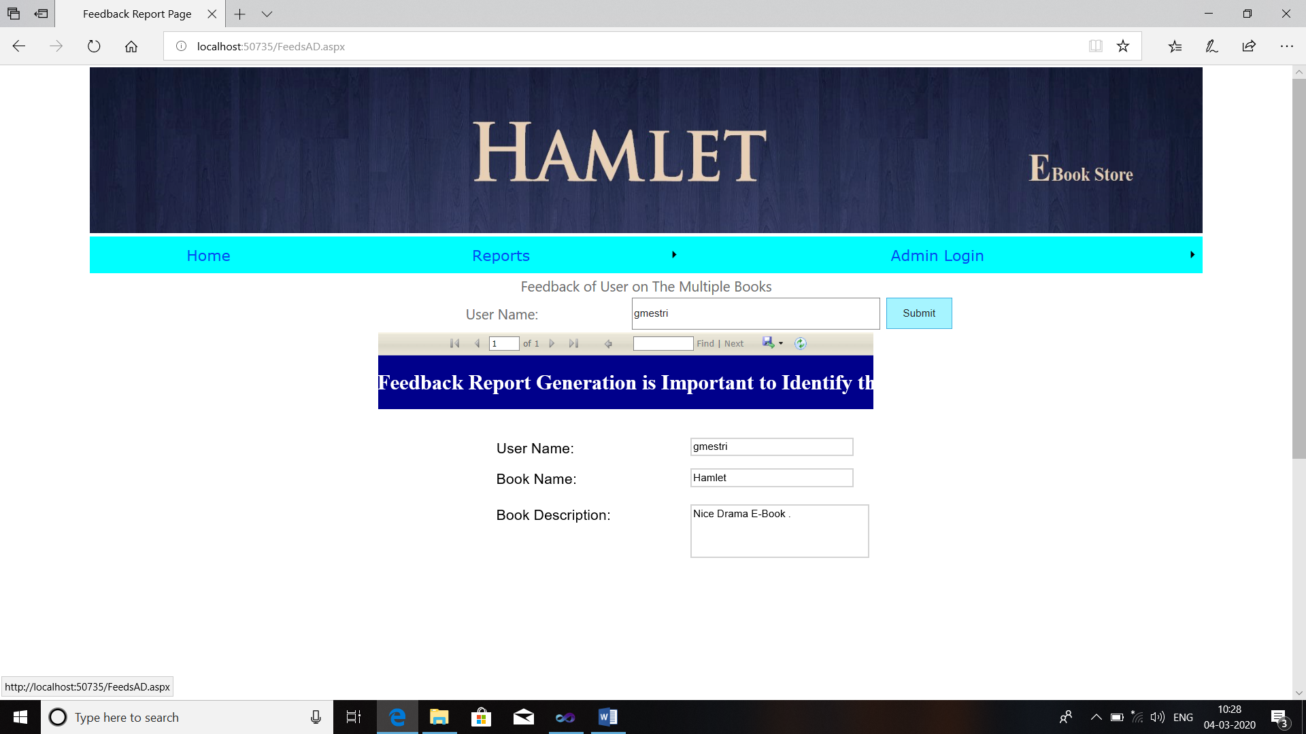

Requirements of User Report:

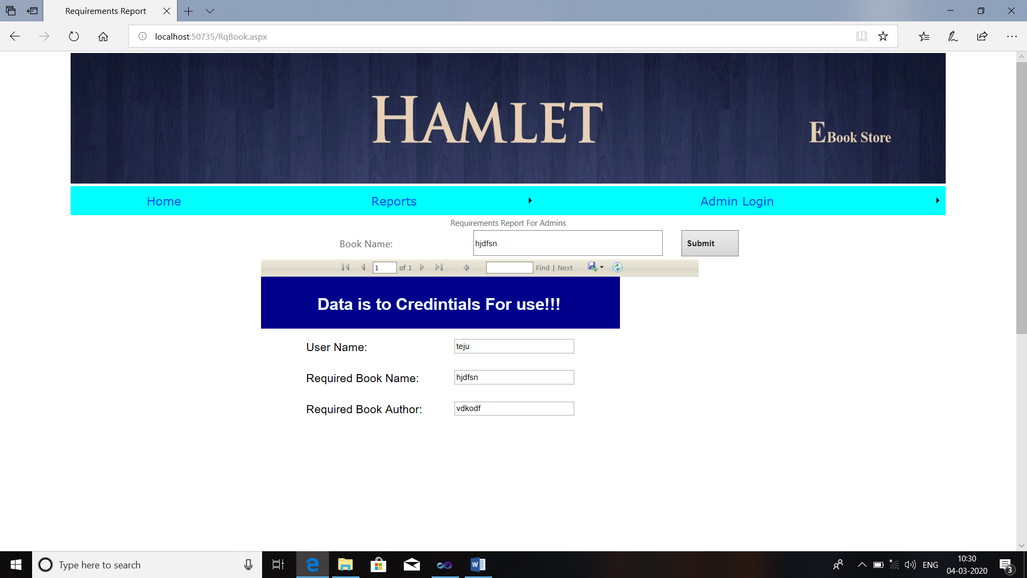

**CHAPTER – VII**

**CONCLUSION**

**Conclusion:**

* This system reduces time and paper work which helps to decreases complication and time.
* The system utilizes for processing of data accurately.
* The Database is design carefully to minimize the redundancy of data.
* The system is design in such a way that further enhancement are ease to implement.

**Future Enhancement:**

* E-Book Store Management System contain the future enhancement of the project the to be related to online selling books and the audio books for the users.
* The web page is contain some free books that helps to development .
* The online systems are the Todays Requirement of life.
* Everything is online in todays world.
* This allows user to know about each other and their current activities.
* E-Book Store Management System is to develop web page which manages records of Book Store.

**REFERENCES & BIBLIOGRAPHY**

1. ASP.NET 4.5 In VS 2010 Professional – Mathew McDonald
2. Mastering VS 2010 – Evanglos Petroutsos
3. Murach’s Visual Studio 2010
4. System Analysis And Design – Satzinger Jackson And Burd
5. Software Engineering – Roger Pressman
6. [www.asp.net](http://www.asp.net)
7. [www.google.com](http://www.google.com)
8. [www.youtube.com](http://www.youtube.com)
9. [www.wikipedia.com](http://www.wikipedia.com)
10. [www.w3school.com](http://www.w3school.com)